**Manual Testing**

-------------------------------------------  
  
Module 1: Testing concepts (Theory) What to test?  
Module 2: Testing concepts (Practical) How to test?  
Module 3: Agile process – JIRA

-------------------------------------------

**Module 1**  
  
**Topic 1: What is software? Types of software.**

Software is a collection of computer programs that helps us to perform a task. Program itself is a code written by developer.  
  
Types of software:  
**1) System software**  
 Ex: Device drivers, Operating Systems, Servers, Utilities, etc. usually used to run the system, for example intelligence software to identify mouse, keyboard, or different OS, OS – is a primary software which is presented as a base of any computer, laptop, mobile phone  
  
**2) Programming Software**  
 Ex: compilers, debuggers, interpreters, etc. – doing some processes when we run the code -developers usually use them

**3) Application software**  
 Ex: Web Apps, Mobile Apps, Desktop Apps – Amazon, Facebook, E-commerce, etc. here it contains a user which might act different ways on those apps.

----------------------------------------------

**Topic 2: What is Software Testing? Why is it required?**

Let’s paint a picture:  
X Bank(company) ------------> IT Company (so X Bank – is a small company that wants to approach to some IT Company and ask them to develop a software for Bank to automate some processes)  
  
XBank has some budget and time, so this attributes are explained to IT Company, and other requirements and ITcompany agrees to all the conditions, and they start developing  
  
IT Company -------------------> will develop the software ------------------------> test ----------------------------> Deliver -----------------------> XBank  
  
**So Testing conduction or software testing should be done because we want to release/deliver quality product to the customer.**

So before delivering to the customer, it’s vital to conduct testing.  
  
**Software testing – part of software development process.**

**Software testing – an activity to detect and identify the defects in the software.**

---------------------------------------

**Topic 3: What is Software Quality?**

Software Quality:

**-Bug-free** (we have to aspire to provide a software with minimal number of bugs)

**-Delivered on time** (because here money play paramount role for a customer, and time=money)

**-Within budget** (deliver quality product by sticking to predefined budget)

**-Meets requirements and/or expectations** (before developing the app itself, business analyst assembles the requirements from the customer, so he got to comply them)

**-Maintainable** (user-friendly and usable apps on the customer’s side)

---------------------------------------  
  
  
  
  
  
**Topic 4: Project Vs Product**  
  
There’s small difference between these two things:

1) If software application is developed for specific customer based on the requirement, then it’s called **Project ()** – for example bank (all the transactions of software are automated using within that particular bank)  
  
2) If software application is developed for multiple customers based on market requirements, then it’s called **Product** (might be used by multiple customers) – mobile apps, WhatsApp, MS office products (based on market requirements)

----------------------------------------

**Topic 5: Why do we need testing?**

Ultimate goal: to release the quality product to the customer.

We should ensure that it’s bug-free, meets all the requirements/expectation according to customer desires.

----------------------------------------

**Topic 6: Error, Bug, Failure**  
  
**Error** – is a human mistake arisen after some task execution, incorrect human action, suppose developer types a program and make occasional mistake, not on purpose – so it’s an error. Normally developer – main character  
  
**Bug** – is deviation of expected and actual result (inconsistency of expected and actual result), ex. Login screen I provide valid login and valid password and I’m supposed to log in to the system successfully, but I can’t do it by even passing valid credentials, so it’s a bug (it’s a mismatch) also named as a **Defect,** usually identified by Tester **Failure –** suppose, everything’s fine, all tested, and we install deployed the apps to the customer environment and in a couple days some user detects a deviant behavior, some transaction gets failed f.e., so it was identified by end user – so it’s a failure. End User

-----------------------------------------  
  
  
  
  
**Topic 7: Why the software has bugs?**  
  
Lot of reasons. At least 5 reasons we can name.  
  
1) **Miscommunication or no communication** (no proper talk between developer and tester, they might expect different things from the software’s behavior and have their own thoughts about documentation/requirement) or the lack of communication is even worse  
  
2**) Software complexity** – really huge software, when there lots of employees, many modules, so 1000 chances to miss some bugs at different kinds of testing  
  
3) **Programming errors** (most of the times concern developer’s side, so it seems that everything’s clear and correct works but improper output according to logic)  
  
4) **Frequently changing requirements** (we started developing but in the middle of the way customer wants to change the requirements and again and again)  
  
5) **Lack of skilled testers** (Testers should have diverse mindset, always think about negative scenarios, should posses good knowledges, check different ways)

**Topic 8: SDLC**

**SDLC** – Software Development Life Cycle

Any IT company assembles requirements from the customer, based on the requirements company will design the application, develop it and finally conduct testing, after it we can release it to the customer  
  
**SDLC** – step by step process used by software industry to deliver quality product to the customer.

**There 3 important P’s**  
**P – People** (workers, employees in labor for company to develop an application)  
**P – Process** (some actions completing by people to aim main goal – provide quality product)  
**P – Product** (whatever we deliver to the customer)  
  
These are 3 pillars for the company. Therefore, People should follow certain Process of creating the software to achieve major goal – providing quality Product to the customer.

Each SDLC has basic phases of development:  
Requirement/Analysis 🡪 Design 🡪 Development 🡪 Testing 🡪 Maintenance  
  
1) **Requirements/analysis** – collecting requirements from the customer (Business Analysts, Project Manager, Product Manager), they make special documentation with all requirements.

2) **Design** – prepare mock-ups and pictures and visual documents concerning developing application, so they(designers) show how app should look like.

3) **Development** – completed by developers, coding, writing programs (back-end, front-end developers) – they create application itself

4) **Testing** – after developing is completed, before releasing, delivering, it we should conduct different types of testing: functional, non-functional, performance, security… By QA, Testers

5) **Maintenance** – deploying the software on customer environment and they start using it there, and all the developing team might be involved in support of this product/project. It depends.

--------------------------------------------

**Topic 9: Waterfall Model**  
  
Old and traditional model, linear model, it looks like waterfall.

At first, we have negotiations and conversations with businesspeople from the customer side, and BA make the corresponding documentation based on clients’ desires and demands. Only after completing this step, the designers may procced creating their documents including mock-ups and frameworks and additional docs, after finishing the design part, implementation begins by developers, after provisioning of software to the testers, QA team can begin testing process, after execution of all tests, conducting the whole testing process we can deploy the application to the customer environment, and finally maintain and support of the end product comes to the picture.

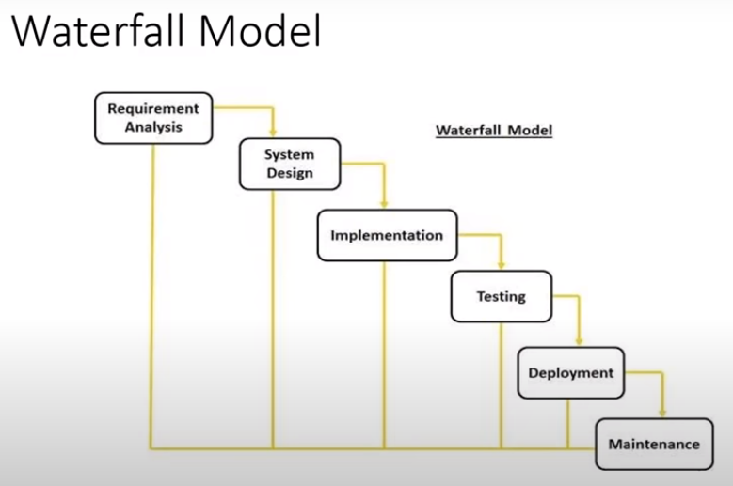

**Advantages of Waterfall model:**  
**1. Quality of the product will be good** (considering that there’s long term process, we have enormous documentation process, every phase each detail is documented, so accuracy is inevitable here)

**2. Since requirement changes are not allowed, chances of finding bugs are less** (cause it’s not possible to change the requirements in the waterfall model, everything is clear, docs are prepared, so it’s a plus)

**3. Initial Investment is less since the testers are hired at the later stages** (cause testers are not needed till the fourth stage(testing), so they can be hired later)

**4. Preferred for small project where requirements are frozen** (Cause every phase has static docs and not dynamically changing)

**Drawbacks of waterfall model:**

**1. Requirements changes are not allowed** (everything is supposed to be according to initial requirements, and if customer wants some changes, there’s pretty much nothing IT company can do about it)

**2. If there’s a defect in the requirements it’ll be detect on the later stage** (Because testers will turn on the project lately some bugs might be unnoticed, unseen on the first stages.

**3. Total investment is more** because revealing any bug on the testing tier will cost more to eliminate it from all the stages, hence consumer will spend some extra costs for rework.

**4. Testing will start only after coding**, late, which increases chances for detecting bugs.

----------------------------------------------

**Topic 10: Spiral model**

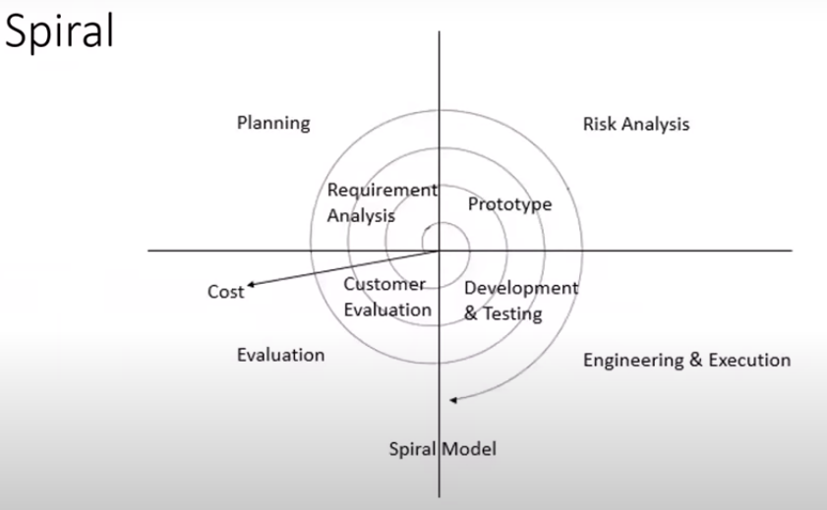

Here we can see different terms, like **Planning** explains gathering the requirements and analysis of these requirements and creating proper documentation,  
And there’s **Risk Analysis** – where we can think how much will it cost, how much staff do we need to provide excellent balance in working process  
**Engineering & Execution** – basically design and development phases  
**Evaluation** – Testing

First part is a planning (gathering requirements and analysis of them) – Second is preparation corresponding documentation, risk analysis – Third is design and Development – Fourth is testing and evaluation from the customer – Fifth is delivery to the customer version1.  
  
Then customer adds some requirements. And the same cycle should be repeated overlapping previous versions of application, and so on. Such cycles can be repeated endlessly.   
  
For example, WhatsApp product – at the beginning there was lack of features, and it looked really dull at first, but then some upgrades were given, and it improved and improved because of many cycles of development according to spiral model (iterative model)

- **Spiral model is iterative model** (repetitive, version-control model)

- **Spiral model overcomes drawbacks of Waterfall model** (i.e., requirement changes are allowed)

- **We follow spiral model whenever there’s dependency on the modules**(cycles), so every cycle will be conducted on top of the existing software, so it depends on previous version.

**- In every cycle new software will be released to the customer**. It’s like mini-waterfall model in each cycle.

- **Software will be released in multiple versions**. So, it’s also called version control model, so we always can get back to the previous versions.

**Advantages of spiral model:**

**1. Testing is done in every cycle, before going to the next cycle**, which is good because testers will always be aware of upcoming bugs and minimize the amount of the defects from the source.

**2.** **Customer will get use the software in every module**. And as development goes customer receives new version of application

**3.** **Requirement changes are allowed after every cycle**, but not in the middle of cycle.

**Drawbacks:**

**1. Requirement changes are not allowed in between the cycle** (only after completing current cycle and negotiation with customer)

**2. Every cycle of spiral model looks like a waterfall model** but in a small version

**3. There’s no testing in requirement & design phase**

**Prototype --- blue print of the software.**First we will get the initial requirements from the customer and after that we don’t develop the software itself, we create the prototype (sample, blueprint)

If customer approves this blueprint development can be started (design, coding, testing).

**Modules: What are modules?** These are parts of application (many of them)

For ex: Gmail includes login, inbox, compose, sent procedure, etc. They all are different modules. Some pieces of software which contain some number of features. Or we can say one feature is one module. So, every functionality we see in the app we can name it a module.

-------------------------------------------------

**Topic 11: V-model/ VV-model**  
  
We call it as a V-model because it’s similar to V shape.

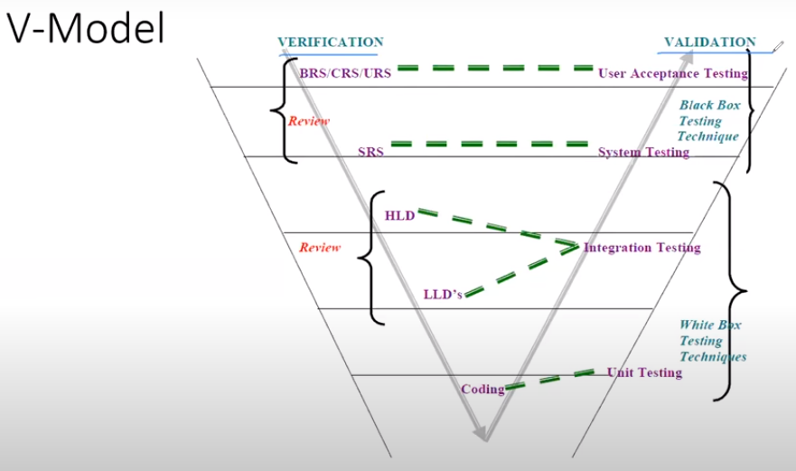

Here one side completes verification and validation parts. Here in every phase, we conduct the testing.

**First phase** is collecting of customer’s requirements. (**BRS/CRS/URS** – Business Requirements Specification/Customer Requirements Specification/User Requirements Specification) – requirements given by customer will be collected in this business document, this document should be understood by businesspeople of the company (Business Analyst). Based on this document testers will conduct User Acceptance Testing (UAT).

**Second phase**. Since Business Doc can not be figured out by developers and testers. So, we need another document based on business requirements. It’s called **SRS** (Software Requirements Specification) which consists of some technical details. (Project/Product Manager) System testing should be conducted according to SRS document.

**Third phase**. Here the designers prepare **HLD** and **LLD** (High Level Design and Low-Level Design) documentation. HLD contains main modules of apps. LLD contains more detailed info about each module. (Prepared by designers). Thus, Integration testing comes to the picture. Checking how different modules interface with each other.

**Fourth phase**. Here coding will start. Developers writing codes (certain modules independently at first). Hence Unit testing will be conducted for approving this stage.

All these phases(stages) were describing the **verification process**

Worth to mention that after preparation of business documents, business analysts or whoever involved in this process should complete some kind of review on created documents, comprising (BRS and SRS). So, this is a documentation testing as a review.  
  
There is static testing which is testing the project related documents. Implying static testing we always talk about testing of documentation. **There are 3 techniques of static testing: review, walkthrough, and inspection.**

**In the validation part we see all the kinds of testing**.

First developers develop different modules. And **Module testing and integration testing** should be conducted by developers themselves because they know their own code. Testers also can do it, but in this case, testers should possess programming language skills. – So, this is called as **white box testing techniques**. With open code.

And then **System testing** phase comes by method of **black box testing**. Basically, testers don’t need to understand a code. Testers should just conduct testing. Black box means we don’t know what is inside the box, just checking if all the functionalities meet customer’s requirements.   
  
And the last step **is user acceptance testing** (UAT) conducting testers along with customer. Also, Black Box Testing Techniques.  
  
**Dynamic testing** means testing the actual software - Unit testing. Integration testing, System testing, UAT.   
  
So, until coding we only can provide static testing of documentation applying diverse static testing techniques (walkthrough, inspection, review), then developers themselves should check their own code as part of module and integration testing and start from System testing testers come to the picture and begin software testing with black box techniques. And then from the point of view of end user testers along with a customer make a group for conducting UAT.

**Verification / Validation – Difference?**

**Verification** checks whether we’re **building the right product** (so whatever activities we do at every stage we’re supposed to ask ourselves if they’re correct or not. If we correctly develop the product based on prepared earlier documents: BRS, SRS, LLD. Points**: focus on documentation, applying static testing techniques.**

**Validation** checks whether we’re **building the product right**. Once the software is ready, we’re testing the software. We’re checking the actual software if it works according to customer’s expectations. After verifications are completed (all the static testing) **validation can be begun (dynamic testing). It focusses on software.**

**Advantages of V-model:**

1. Testing is involved in each phase

**Disadvantages of V-model:**

1. Initial investment is more

2. Documentation is more

--------------------------------------------

**Topic 12: Review, Walkthrough, Inspection**

Static testing techniques:

* **Review** (suppose If I’m given with documents, so I’ll read entire document checking if all the things are there and if the information are correct, so **correctness and full documentation** should be conducted on documents. Different types of reviews:  
  **Requirements review** (given by customer**); Design Reviews** (Diagrams, pictures of LLD, HLD documents); **Code review** (by developers, sometimes one developer check another**); testing plan reviews** (different documentation created by testers needs review); **test cases review**. May be done by anyone in the team. **Can be done by one person**!
* **Walkthrough** (**Informal review** – don’t have specific plan, don’t have special meetings with team members for this event, so may be conducted **at any time in any place**. Author reads the document or code and discuss with peers. So, this **process includes at least a few people**. This arrangement is not pre-planned, doesn’t have any minutes of the meet (cause it’s informal and not pre-planned).
* **Inspection** (**more formal**, we have to pre-plan, invite team members, **not only testers**, so send email to team members, 3 types of people are there. a) reader; b) writer; c) moderator  
  Reader – the author of the document; Writer – would write some questions and queries concerning the reading parts of the author; Moderator – between author and other members of the team, he/she is like organizer of the meeting. Lot of people might be involved. Project Manager, BA, Developers, Testers**. Author should have a proper schedule** which must be send in advance to the team members.

-----------------------------------------

**Topic 13: Dynamic testing techniques**

**Unit testing** (conducted usually by developers, they know their own code, so it’s much simpler for them to check if all works as it’s supposed to)

**Integration testing** (Integration many modules, components combined with each other by developers, usually they check if everything works correctly if modules respond expected behavior and so forth)

**System testing** (Actual testers perform the testing if everything is proper according to customer anticipation, requirements)

**User Acceptance testing** (by testers along with customer, set up the exact environment where customer wants to work and install there the software and they together test from the customer point of view the main flows of application, main features, transactions, correlation with database and so on)

------------------------------------  
  
  
  
  
**Topic 14: QA & QC & QE**

**QA Vs QC:**

**QA is process related** (they always will stick to the process, define the process, ensure that rest of the people perform properly, high management people encompass the QA sphere. From the requirement to delivering final product, make sure all the people follow the right way of development.  
  
**QC is the actual testing of the software**. They involved exceptionally in the testing phase of the whole process of development (if the software working according to customer’s requirements or not). So, QC – the actual the natural testers.  
  
**QA focuses on building in quality** (to deliver the quality product to the customer. So, we must follow a certain step of process. So, QA is involved in every step of development and play important role throughout whole cycle, keeping track on quality everywhere starting from creating proper documentation  
  
**QC focuses on testing for quality**. Testing, why do they need to do that. To provide quality product to the customer. So, they follow process only at the testing stage. Testing to detect bugs, fix them and continue.

**QA is preventing defects** (So the task of QA is prevent appearing defects in the future at any upcoming stage (design, coding, testing) that’s why QAs involved in the process from the start.   
  
**QC is detecting defects** (Testing stage they stick to this part of the development. So their main work Is to find as many bugs as they can, that’s their bread to eat.

**QA is process oriented** (They always talk about process, talk about the requirements, design and all the rest stages)  
  
**QC is product oriented**. It means that during testing QC preoccupied and worried about product. Main goal main intention directs to quality of the product, finding bugs.

**QA for entire life cycle** (involved in every phase)  
  
**QC for testing part in SDLC** (involved in testing stage)  
  
So to sum up QC is subset of QA  
  
  
  
**QE – recently appeared term**. Means Quality Engineering.   
Write the code to check/validate for testing the software. So, **QE means automation engineer**. QE is a team comprising the auto testers. So, QE they’re improved, innovated, **enhanced QC** who have **ability to write the automation scripts** for testing the software.

------------------------------------------  
  
  
  
  
**Topic 15: Levels of testing**

It means step by step, **after one level of testing goes next one**.

* **Unit Testing** (small component, tested by developers usually)
* **Integration Testing** (communication between the modules, their behavior, etc.)
* **System Testing** (testing all functionality of application if everything responds to customer requirements)
* **User Acceptance Testing** (UAT) (Tester along with users/customer will conduct tests)

**Unit testing - related points.**

**1.** **A unit is a single component or module of a software** (so big software contains lots of features, components, functions, i.e., Gmail inbox – may be deemed as one module or deleting message. Programmers tend to write a simple code for testing this particular module.

**2.** **Unit testing conducts on a single program or single module**

**3.** **Unit testing is a white box testing technique**. (Because we know the internal logic of the code)

**4.** **Conducted by developers**.

**5.** **Unit testing techniques**:

**Basic path testing** (each line of code/program should be covered at least ones)

**Control structure testing**

**Conditional coverage** (if/else conditions, switch conditions, verifying the most important conditions) – positive and negative input ----------> output checking.

**Loop coverage** (looping states: for, while: also checking most common things concerning looping stuff)

**Mutation testing** (repetition: passing different types of inputs) – checking the outputs.

**Integration testing – related points**

**1. Integration testing performed between 2 or more modules** (It’s like in banking apps: check balance – one module, transfer money – one module, so communication between them should be passed)

**2. Integration testing focuses on checking the data communication between multiple modules** (so i.e. I check output from one module and transmit this output as an input for another module)

**3. Integration testing is white box testing techniques**. At the code level developers can conduct an integration testing, by verifying one module code-wise, another module and their mutual bind. But testers sometimes may conduct integration testing. That happens at the application level. So, communication on UI, it can be presented as a small part of application given by developers especially for conducting the integration testing on application level.

**Types of integration testing:**

**1) Incremental integration testing** (most of the times we use this type. Def: Incrementally adding the modules and testing the data flow between the modules. First, we have one module A, then we’ll add module B and check the communication between them, later we keep adding new modules and testing the connection between them and so on:

**a) Top-Down approach** (Ensuring the module added is a child of the previous module, so it seems like we’re getting down from the top, i.e.: ‘Compose’ module of Gmail is a parent module, ‘Sent Items’ module – is a child module; so, we’re validating the process of composing the messages which later should display in the sent items.)

**b) Bottom-Up approach** (Ensuring the module added is the parent of the previous module, so we’re getting up from the bottom, i.e.: so as in previous example, we’re testing backwards way, first ‘Sent Items’, then ‘Compose’, here we’re integrating parent modules on top of previous ones.)

c) Sandwich approach – combination of Top-Down and Bottom-Up approaches.

**2) Non-Incremental integration testing** – adding all the modules in a single shot and test the data flow between these modules. Here are drawbacks:

- We might **miss data flow** between some of the modules.

- If you find any defect, we **can’t understand the root cause** of the defect.

**System Testing – related points.**

**1. Testing over all functionality of the application with respective client requirements** (checking if any feature of software is working properly complying the customer’s requirements, not touching the code)

**2. Black Box Testing technique**: on UI, on the application level without observing what’s located under the bonnet

**3. This testing is conducted by testing team** (requirement understanding is very important)

**4. After completion of component and integration level testing we start System testing**

**5. Before conducting system testing, we’re supposed to know the customer requirements** (to be prepared and get fully ready in ahead of time)

**6. System testing conventionally focuses on these aspects:**

**a) User Interface Testing GUI** (elements alignment, color, font, all the images, navigating…)

**b) Functional Testing** (functionality: i.e.: login, checking balance, generating report…)

**c) Non-Functional Testing** (security, performance (speed of app), compatibility…)

**d) Usability Testing** (Each step on app will be documented, for user-friendly spirit).

**User Acceptance Testing UAT – related points**

**1. Normally conducting by customers or users**, verifying the requirements, but **developers and testers can be involved** in this process to contribute to the customer whatsoever.

**Alpha testing** (Users, customers will conduct the testing in the testing environment, so they will come to the company’s territory and do the testing on their side)

**Beta Testing** (application now is installed on their environment and test software there) – afterwards software is going to production.

**Topic 16: System Testing Types:**

First, we got to understand that apart from having good skills of testing, we should **know the requirements**, we have to understand all **the flows of application** to provide an excellent work as a tester, so before getting deep into the testing itself we need to **read the specifications thoroughly** and clearly figure each functionality (SRS, LLD, HLD..).

We’re going to do a lot of activities as a tester. Read and understand the requirements, **prepare the test plan, test cases, check lists, then execute our test cases, find bugs, reporting these bugs and test execution report will be there**.

Different types of testing at system testing level we should conduct. But first theoretically speaking let’s discuss them.

System testing mainly focuses on four arear as we discussed recently: GUI Testing; Usability Testing; Functional Testing; Non-functional Testing. From these kinds we may mark functional testing because this is the most important type of testing.

**- GUI Testing:**

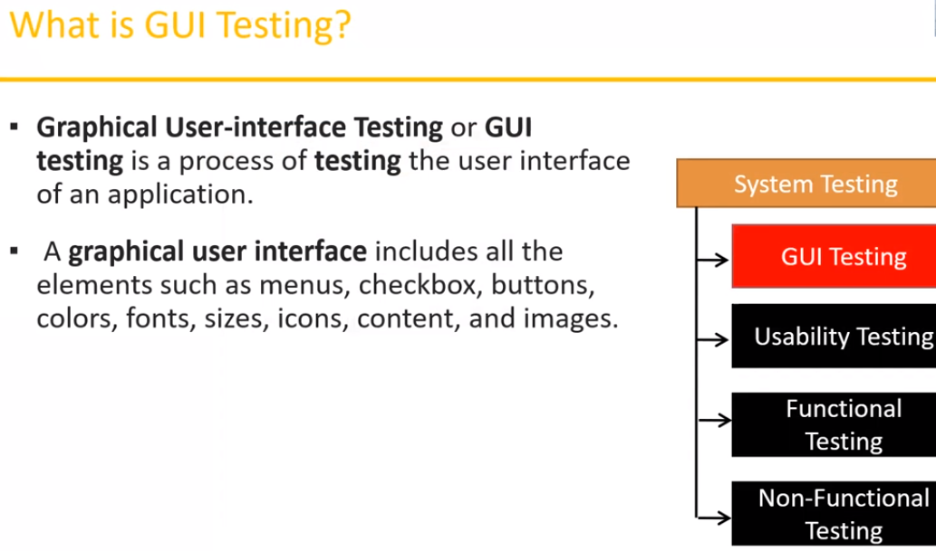

User always interact with an app through the front-end, but the actual application written, coded at the back-end obviously, so **by GUI we may imply front-end** part of application.

So GUI Testing is a process of user interface of an application. So here focusing not exactly on functionality**, the elements – are our scope** here.

Basically Testers or Test team may prepare some checklists in advance for testing the GUI, normally in the Excel sheet, but whatever. And this is how it can be looked like (all the elements and the brief or full info about different elements we can find in LLD, HLD documents provided by designers where they should display all the characteristics, parameters of each element, they may also draw mock-ups, wireframes, screens and so forth):

* Testing the size, position, width, height of the elements.
* Testing of the error messages that are getting displayed (f.e. there’s a textbox allowing 8 characters but I typed 10 characters, so after attempt to go further there might be an error line with warning or heads-up or smth)
* Testing the different sections of the screen (like header, footer, main part, etc.)
* Testing of the font whether it is readable or not
* Testing of the screen in different resolutions with the help of zooming in and zooming out(elements should be displayed correctly without overlapping and other drawbacks)
* Testing the alignment of the texts and other elements like icons, buttons, etc. are in proper place or not (developers may mismatch the location of element and this we have to check)
* Testing the colors of the font(colors would influence on level of user’s attraction, so very important)
* Testing whether the image has good clarity or not (high quality, not blurry)
* Testing the alignment of the images (where the images are placed)
* Testing of the spelling (all the texts on the screen should go without any grammar or any kind of mistake)
* The user must not get frustrated while using the system interface (so user hopes to enjoy with time spending on the system)
* Testing whether the interface is attractive or not
* Testing the scrollbars according to the size of the page if any (if pages are small with a little amount of content to allocate, the scroll bars will not appear; as we’re replenishing the page with new information, the scroll bar should come. Smth like that)
* Testing of the disabled fields if any (suppose a textbox is there but we can interact with it, it has gray color or something, checking such functionality)
* Testing the size of the images (appearance: width – height, should not have the huge size, should make sure they have less size, it all impacts on time of page loading)
* Testing if the headings are properly aligned or not (should be in big size)
* Testing of the color of the hyperlink (navigating to another page, like behavior when we’re clicking, hovering, changing color after clicking and so on)
* Testing UI Elements like inputs, calendars, button, textbox, text area, check box, ratio buttons, drop downs, links, etc.

**Usability Testing:**

It implies **easiness, simplicity of application**; as a user I want to have easy access to every feature, I want to manage in a free manner and enjoy the beauty of the software. There’s a help menu in almost every software, so we contribute to user by providing such help. **“Context Sensitive Help”** is a special thing that should be given to the users, wherever he/she senses difficulties they have to get the opportunity to find an answer. Lile in different applications by pressing F1, F2 buttons user enables to look up for a solutions. **Manuscripts** comes to the picture with each step throughout the whole functionality of software when product gets delivered to the customer.

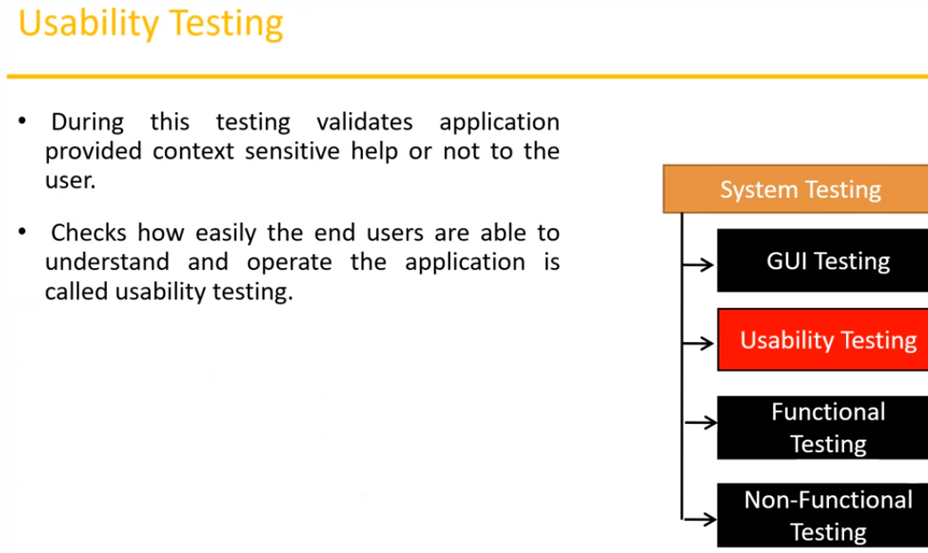

Sometimes we can refer to developer to simplify an application if we discovered earlier that it’s not so easy and some functionalities, some features might be hard to get to user, so somewhere in some scopes of application it’s not **user-friendly**. Complex things are not good.

**Functional Testing:**

This is where **we concentrate most** of the time. That’s the place for us to splash out our collected energy, our emotions. Here we may represent various types of testing. So, this type of testing is composed of many subtypes.

**What is functionality**? It’s behavior of the product/application/software, how it behaves, according to customer requirements or not. So here comes **focus on the functionality of the elements**. And bonding of the elements, sometimes we consider functionality several elements as a whole. We’re not checking the UI (where textbox is placed, what size or color whatever), but in functionality we observe the **behavior of software** of separate features (F.e. authentication of user: what response we’ll receive after providing proper credentials, whether there’s a log in to the system or not). How our features should work responding to all client’s expectations.

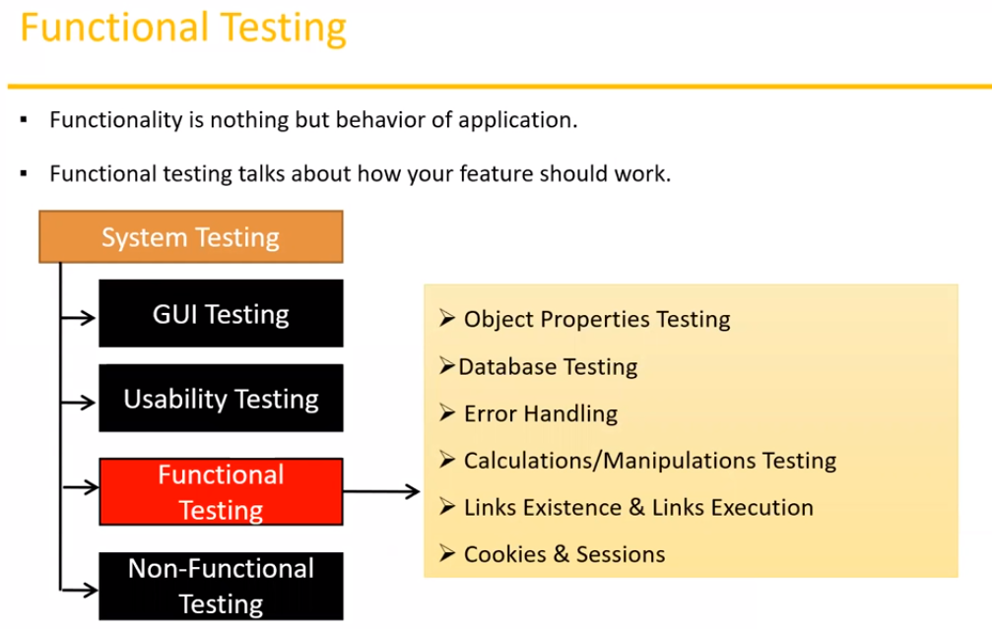

There are some subcategories of Functional testing presenting on the picture. Let’s discuss them and make corresponding conclusions.

**- Object Properties Testing** (object is an element; every **element on the web page has its own set of properties, attributes**; f.e. enabled or disabled input box; radio button elements and how selected option automatically unselect another radio button; and dropdown – if It provides only single option at a time or not; so we have to verifying all the properties of objects)

**- Database Testing** (you have to need some **basic SQL commands**, need to posses some knowledges about databases; internally we have to do a lot of database testing; kind of back-end testing; as a tester we mainly focus on **DML(Data Manipulation Language)** operations; data will be stored in remote database server, as a user of course I can not see the database; **So when I conduct testing on UI, I can insert some info, edit or delete or anything, along with that I should check proper behavior from database in response on my actions**; Or sometimes it can work backwards; According to documentation or via communication with my team members I should get to know which table stores what. **INSERT – UPDATE – DELETE -SELECT**… (**Gray Box Testing Technique**). Apart from that, having more professional skills we can provide **table level-validation** (how many columns, **what kind of data** may be put inside each field, connections between tables, **verifying functions, triggers, procedures, indexes, views**) that takes some in-depth SQL skills.)

**- Error Handling** (mainly **focusing on error messages**, when I perform some incorrect action on UI **application should displays some message that I’ve done some mistake**, otherwise user may not realize what happened and why system generated the error – during testing application), Meanwhile all the information about error messages usually presented in SRS documents, some links on this topic might be in HLD, LLD documents. Error messages **must be readable and in simple language** **and understandable.** Like by **passing the username and password** into log-in box, something goes wrong error message should be ‘**invalid username’ but not ‘incorrect data’**)

**- Calculations/Manipulations Testing** (sometimes an application **computes some calculations** if there’s a banking software for example: **total balance now is 50000**, after **transferring 20000** we should check updated account **balance that it’s become 30000**, smth like that. We must conduct testing with **valid and invalid data** also, and surely **using testing techniques**. Focusing on data. Providing negative numbers, infinity numbers, decimal numbers, *, (, ^,#,@ symbols as well. )

**-Link Existence & Links Execution** (this concern **exceptionally web-application, not desktop, not mobile**; where exactly **links are placed** according to the document – **existence**; performance/**navigating** to proper sites after clicking or not – **execution**. There are 3 types of links: **internal, external, broken**; internal means it’ll jump/scroll to certain content on **this particular web** page, external will navigate to **another webpage,** broken link **doesn’t work**; sometimes developers might drop off some broken links on the web page for later purposes.

**- Cookies & Sessions** (it also triggers **only web application**; **cookies are temporary smart files** storing on our computer and **creating by browser** for later applying. F.e. providing login and password to some social network I close the webpage, but soon I’ll come back to this social network and there’ll no need to write my credentials again, **the system will open my home page immediately because of cookie files**, or at some retail web site you put something in the cart and leave the site after a while you again visit this site but **all products you preapproved before are selected and storing in your cart because of cookie files**.   
But **sessions will be created on the server site**; for ex.: I log into the system and **stop doing any activities on the web page**. After 10 minutes of wait I resume the work but **system’s asking for providing login and passwords again** because **session was suspended**. Whenever I open some application the **time slot will be started on the server side**, the moment I stop working on the application, server begins counting **how long I haven been inactive** after some time of wait until the peak value server will **terminate the work and log out** automatically. It occurs for **security enhancing**.  
These things we **must test** as part of our functional testing.)

**Non-Functional Testing:**

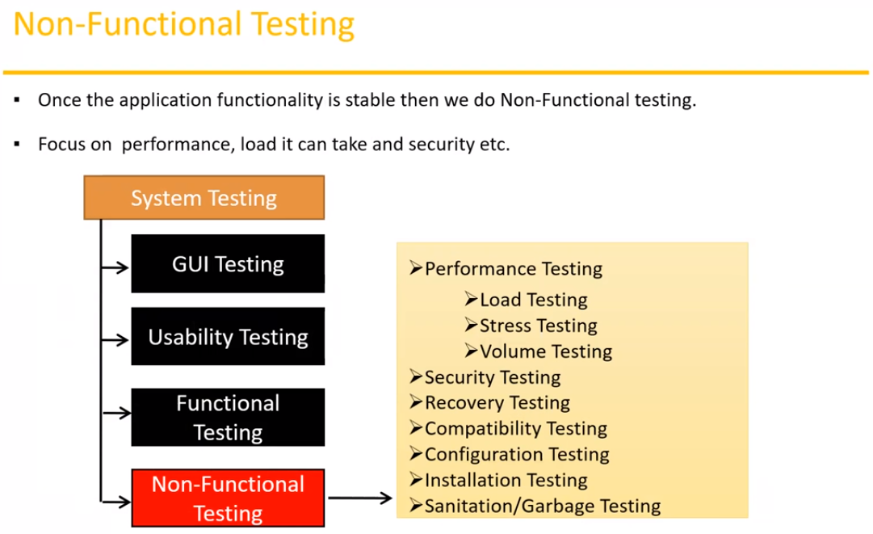

Conventionally, once functionality is stable, then we can move ant test non-functional things. Mainly **focuses on customer’s expectations** not on customer’s requirements. Let’s see the example. Here’s a difference. Banking application: transferring, balance, reporting and so on are features and they go under category of customer’s requirements; but sometimes loading is low, or application is insecure it should not be like that, software must be reliable, available, safe, compatible, and so on – these things are called expectations. For example, application should be stable with high speed even if this app is used by thousands of users. Normally to conduct non-functional testing there are some educated people majoring in this sphere should be involved in the process. Because it **requires high-volume hardware, security testing tools, special environment** and devices are required.

**- Performance testing** (we can say **speed of the application**, how software handles enormous quantity of people using it simultaneously; should be done on web applications.)

**a) load testing** (increasing the load (multiple users) on the application slowly; checking the **speed of responses**, loading of the application. It also should be mentioned in customer’s requirements, we cannot replicate in reality, so we’re using some set of the tools; **gradually enlarging the load**; we must check if there’s any **chance to breakdown** on some crucial level, **what’s benchmark**; there different metrics.)

**b) stress testing** (rapidly, **sharply increase/decrease the load** on the application; checking speed of the application; so start checking with 5 users, **then drastically increase** to 50 users**, then suddenly reduce** to 20 users, and **raise the benchmark** to 100 users – that’s stress testing, it happens in real scenarios ; checking **if server goes down** and make decision whether we need some extra servers or not. If server’s down – define the mark where it still works well and were not.)

**c) volume testing** (size; **how much data** can application handle; **how much capabilities**, because there’s a case when somebody **uploads huge data**, so such situations we must check.)

**- Security testing** (how well our application provides security; we’re mainly focused on **authentication** (user is valid or not) and **authorization**/access control (I’m able to login to an application but with some constrained access to resources) – permissions of the valid user;  
Hacking, protocols level testing dedicated to security specialists, not regular tester.

**- Recovery testing**: (if I lost something, I deleted something I should be **able to take that back**, by mistake I performed some incorrect transaction or something I need **to get to restore, revert**. For ex. I was composing file in Gmail, but then blackout happened, and System shut down; after I log in Gmail again it should be there in the draft state)

**- Compatibility testing** (application should be compatible with **various environments**.)

**forward compatibility** (our software should be able to be upgraded to new version on top of obsolete version, so from 1.2v goes on top 1.1v without any errors)

**backward compatibility** (the opposite situation)

**hardware compatibility** (our software should be installed on some certain environments, is it working on different hardware configurations, various OS: Windows, Linux, Mac)

**- Installation testing** (test the installation process, each screen is coming properly or not, whether they are easy understanding; installation should not be very complex, and also un-installation process(removing all the files belonging to software, are they deleted or not))

**- Sanitation/Garbage testing** (there might be some extra functionality which is not in the requirements, we always should consider such situation as bug, so we strive to remove unwanted stuff from our application; this is called sanitation/garbage – means we must throw it out)

**Comparison between Functional and Non-Functional.**

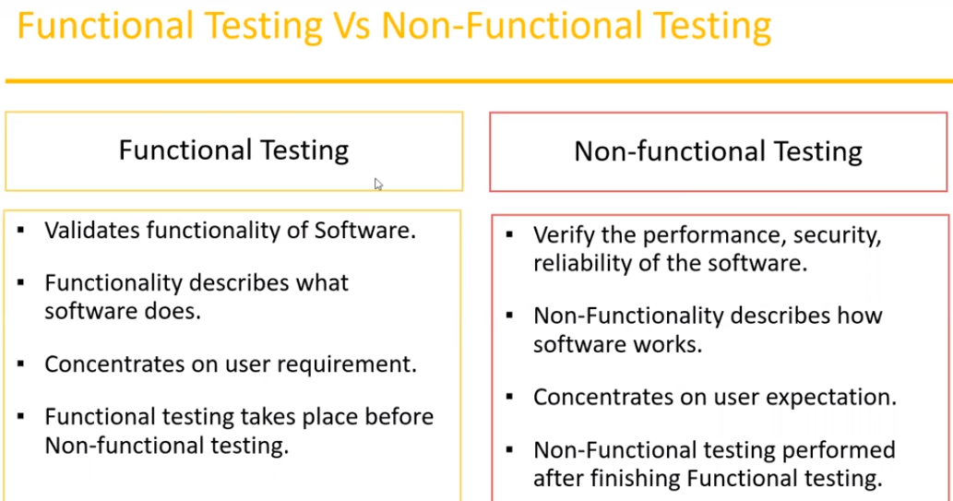

----------------------------------------------

**Topic 17: Software Testing terminology**

**1. Regression Testing:**

Testing conducts on **modified builds** to make sure there’s **no impact on existing functionality** because of changes like adding/deleting/modifying features. We must verify that **nothing happened to previous working fine functionality** after bug fixing process from developer.

It can be done **in 3 different ways**:

**Unit Regression Testing**: it means that we’re testing only the changes/modifications provided by developer, so we must check **only that particular component and components related to this component in this exact module**.

**Regional Regression Testing**: it means testing the **modifies module along with the impacted modules**, so kind of integrational regression testing, because it may **have influenced other modules**, that we have to check; and sometimes **meeting can be organized** concerning impact analysis where Dev and QA can discuss and **analyze impacting functionalities** what will be the scope for testing or something.

**Full Regression Testing**: it means we will **test every module** (testing main feature & remaining part of the application) For ex.: dev. has done changes in many modules whilst he/she was fixing some bug maybe a bunch of bugs, so developer **touched many modules**. Therefore, we’ll conduct one round of full regression.

**2. Re-Testing:**

Re-test the same functionality/feature/component **we’ve already checked**, but there was **a bug**, so tester had to report it to the developer. And now It **got fixed**, so we **must verify this feature works perfectly fine now**. If not: we resend/**re-open** this bug again to developer. If it works correctly, **we close** the bug; Of course, we will check that on new and renew build(release).

**Example of difference Re-testing Vs Regression testing:**

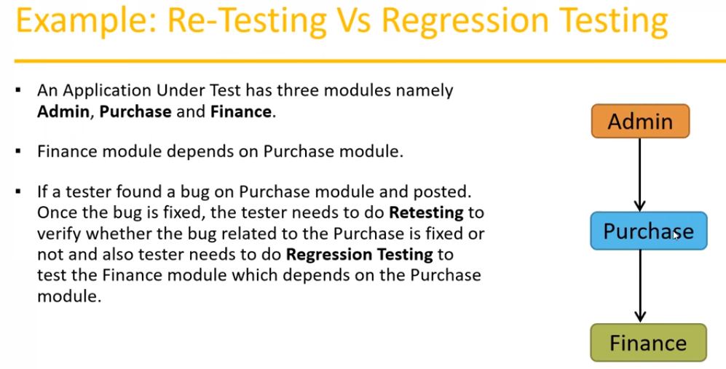

**3. Smoke Testing:**

After Developers’ team transmits a software to Testers’ team, first basic things we have to check are **installation process** if all the files installed or not, if software successfully has **been installed on QA environment** and checking some main features of application, home page, some **substantial links and functions** and so forth. We **don’t have any specific test cases** or check lists, we just verify the build, so basically, it’s built verification testing. Especially **in the beginning level** of development, we usually don’t get a **stable build**, so smoke testing is very important. We need to check if build is stable or not. Can be done **by testers or developers** as well.

**4. Sanity Testing:**

Basic functional testing, testing should be **conducted on high level**. Conducted by **testers only**, once the **build is stable** sanity testing comes to the picture. If sanity testing, and hence smoke testing was successful, passed then we could **accept the build** from developers, if it got failed, we **can reject** the build and developers must fix the build and provide new one.  
  
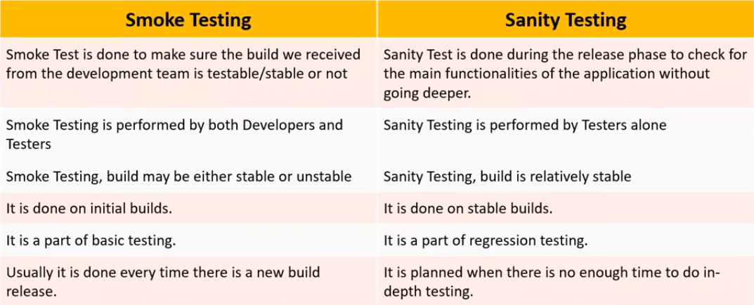  
  
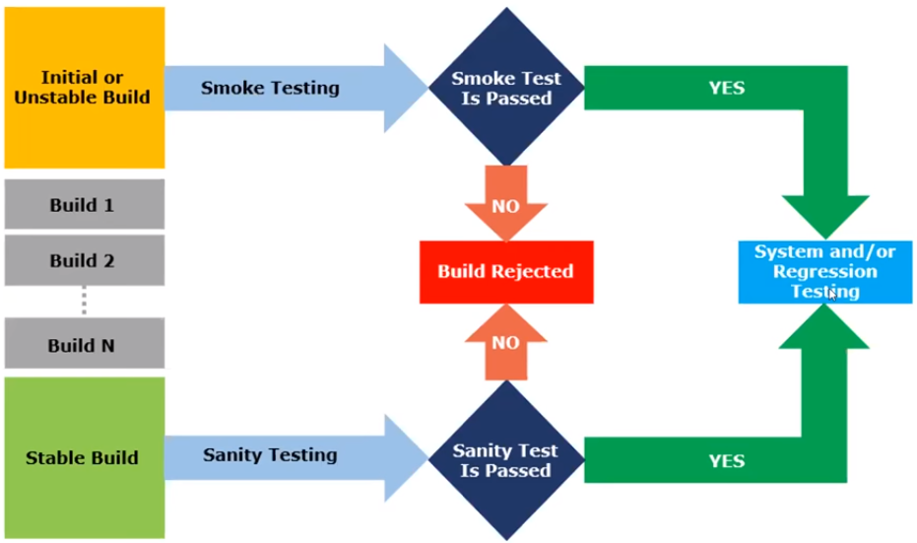

**5. Exploratory Testing**

We must **explore the application**, understand **main features, possible risky scopes**, places, desirably document it all for later testing process. This kind of testing conducts **without any earlier prepared document** (no requirements, no SRS, no LLD or HLD, no test cases). We make such testing when the **application is ready, but requirements haven’t been composed** yet; but once in a while it’s not all bad to explore the functionality first to ‘look and feel’ the software; identify all the probable scenarios. It **depends on tester’s experience**. Suppose tester has a big experience in the past, so it would be easy for him/her to conduct such kind of testing.  
  
**Drawbacks of exploratory testing:**

a) You might **misunderstand** any feature as a bug and any bug as a feature since you don’t have requirements

b**) Time consuming** (so it may incur a lot of time)

c) If there’s any bug in application, you **will never know** about it.

**6. Ad hoc Testing**

Testing an application **randomly without any business requirements documents** or test cases; and it’s not according to any test plan; based on **previous experience** of tester; we don’t have any specific time management for this kind of testing, it can be **conducted at any time**; the main intention of testing is to **break the system**, find defects in the kernel level. Supposedly tester should have some knowledges of application because he/her some **experience in the past**, unplanned activity.

**7. Monkey/Gorilla Testing**

Testing application **randomly without any test cases or any business requirements** document. Here tester **doesn’t have any idea of application**, how it’s supposed to work; f.e.: gaming applications: disorderly clicking on buttons, scrolling, swiping for purpose to get to know how it works **without previous knowledge**. It’s like monkey tests some app. Also, Informal kind of testing.

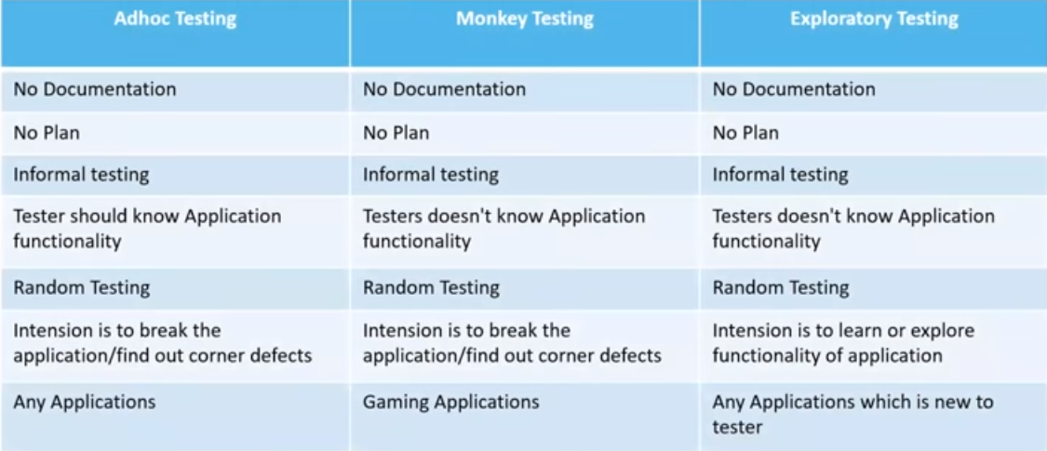

**8. Positive Testing**

Testing an application with **valid inputs**, it checks if software behaves as expected by **providing positive proper inputs**; for example, field accepts numbers from 0 to 99999 and I enter any number from this range. It means I’m conducting positive testing.

**9. Negative Testing**

Testing an application with writing down **invalid inputs**. It checks whether software behaves as expected **with negative inputs**. For example, field accepts numbers from 0 to 99999 but I enter some char symbols or any keyboard’s symbols (“d$^#6$!) – that way I’m conducting negative testing.  
  
  
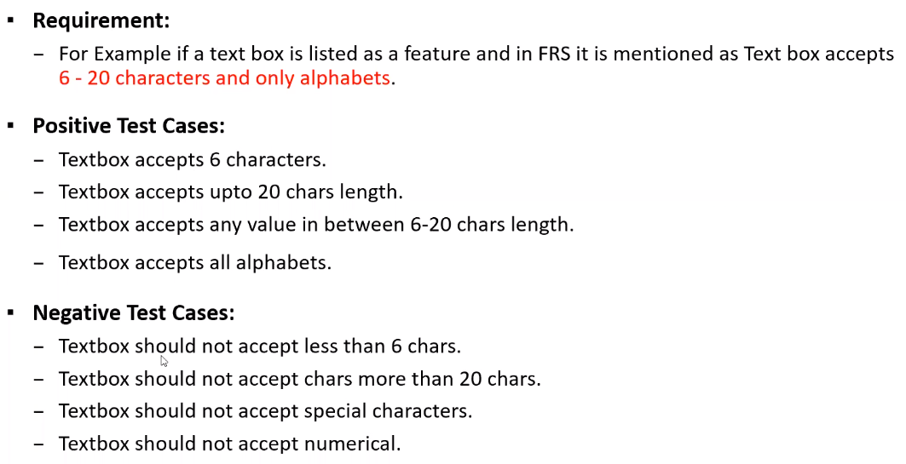

**10. End-to-End Testing**

Testing **the overall functionalities** of the system including the data integration among all the modules; It’ll cover sequentially all the **basic components according to business requirements**, vital trail from the beginning (log in) to the end (log out). For Example:   
  
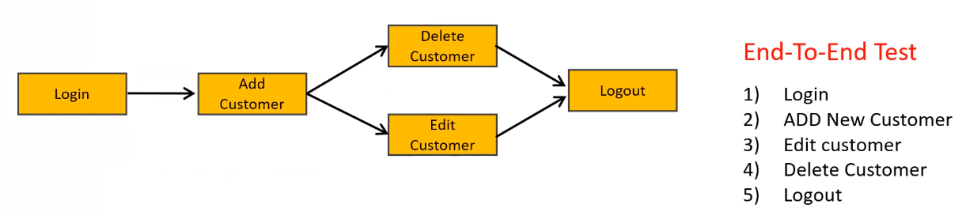

**11. Globalization Testing**

Sometimes applications may be supported **globally**. It implies that our software is working in **different countries**, maintaining **various languages** related to **diverse cultures**. There are some formats, **currency** **mobile formats, address formats**. For ex.: Facebook.com supports many languages and accessible in different countries. Hence, it’s globalized.

**12. Localization Testing**

Sometimes applications may be supported only in **some certain countries**, areas of the world or even encompass just **one country/nationality**, so the software would incorporate only **one language**. Thus, we’ll also check there’s **specific currency format**, phone number format and address format as well. For ex.: CityBus app is only supporting Cantonese language (Hong Kong). So, this is localized product.

---------------------------------------------  
  
  
  
  
  
**Topic 18: Test Design Techniques**  
  
When we perform testing usually, we need some **test data**, set of data for performing positive/negative test cases. Different type of data we’re supposed to prepare. And we must **prepare this data by using test design techniques.**  
Main usage of employing test design techniques:

* **Reduce Data** (for example: various combinations of data we must prepare for testing login/password text boxes: like positive scenario for login and negative one for password is one data, the backward case – second data and so on – to cover all the areas of the feature) so we’re trying to reduce the data to cover everything by applying test design techniques.
* **Comprehensive Coverage**

There are 5 test design techniques we’ll consider:

- Equivalence Class Partitioning (ECP)  
- Boundary Value Analysis (BVA)  
- Decision Table based testing  
- State Transition  
- Error Guessing

**1. Equivalence Class Partitioning (ECP)**

We need to **partition data into different classes**, and we can select the data from any class according to test and implement this data to some certain test case. It’ll substantially **reduce** the number of test cases and **conserve** much time. We more **concentrate on the value** we’re entering.

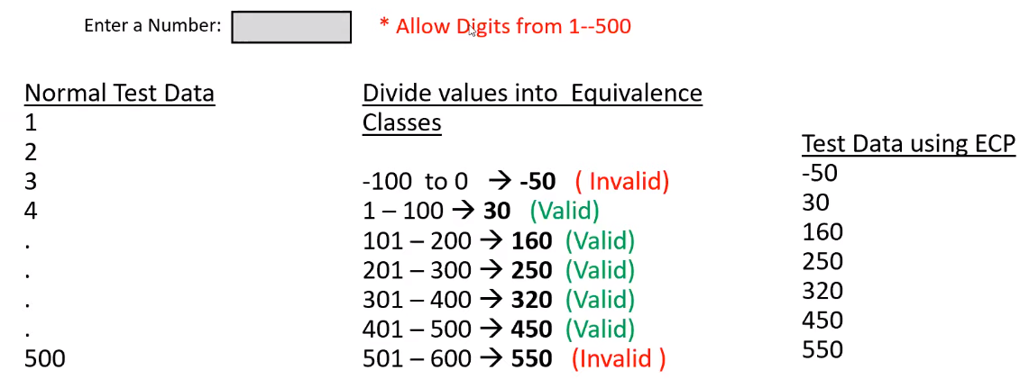

So here we’re portioning our probable numbers to groups/classes, first class consists of negative numbers and zero; second class is from 1 to 100; third class is from 101 to 200….; seventh class is from 501 to eternity. Thus, instead of providing over than 500 tests comprising of each valid and some invalid values, we arranged 7 tests by taking out one value from each group. This is how we can divide all the possible inputs into classes. We covered all the ways and reduced data.   
  
Here's another example:

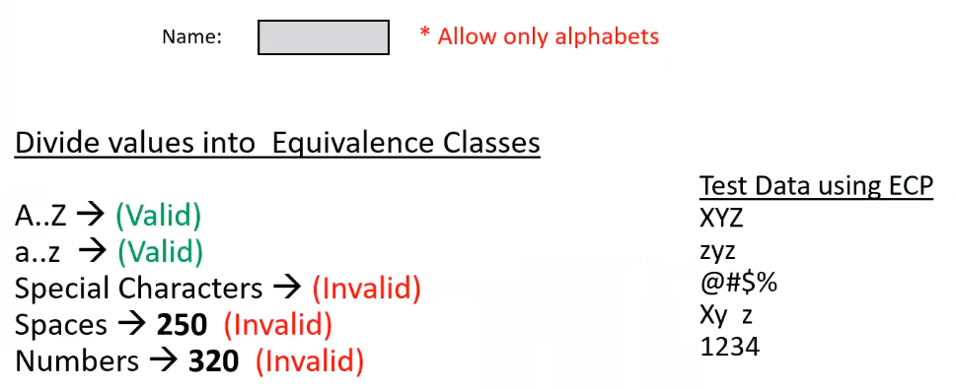  
  
Where we’re testing input box accepting only alphabet’s characters, so we need to create partitions to delimit our data; so, by arranging 5 groups we may take just one instance from each partition.

**2. Boundary Value Analysis (BVA)**

Here we’re more **focused on boundary** of the values.   
On the example below I have a picture where I need to input age from 18 to 35 included. So I need to assemble the test data by checking boundaries. Here 18 – is left boundary, 35 – is right boundary. I’ll take values 17,18,19 (surrounding left boundary and left boundary itself) and 34,35,36 (surrounding right boundary and right boundary itself) and check those inputs.

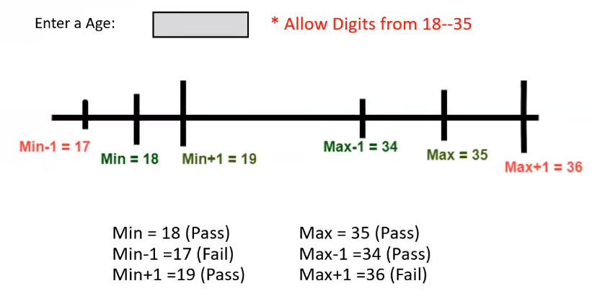

So **ECP and BVA** testing techniques we use when **it comes to Input Domain Testing** (testing where we’re verifying text boxes or input fields).

**3. Decision Table**

This technique might be also called as **Cause-Effect Table**; usually used when we have more **conditions and corresponding actions**; we have to cover all the conditions, at the same time we have to cover all the actions; we deal with **combinations of inputs**.  
  
Example (transferring money online to account which is already added and approved)  
  
**Conditions:**  
- Account already approved

- OTP (one time password) matched

- Sufficient money in the account  
  
**Actions:**  
- Transfer money

- Show a message as insufficient amount

- Block the transaction in case of suspicious transaction

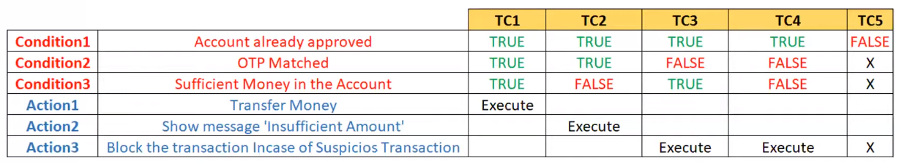

So overall out of 3 conditions we elaborated 5 Test Cases. In response on those conditions, we’re expecting to receive one of those 3 actions (as **expected result** in test case). So, whenever we have **number of conditions and matching actions** this technique becomes very useful.

**4. State Transition**

One of the techniques. Here we may **change the state of application by** **changing input conditions**. Here we somehow test the **behavior of application**; tester might check the behavior by giving **various input conditions in a row**. Generating both positive and negative scenarios to consider different system’s states. So, transition represents changing the state of software.

Let’s observe banking application and we’re now at the login/password page and we’re about to enter our credentials to proceed further.

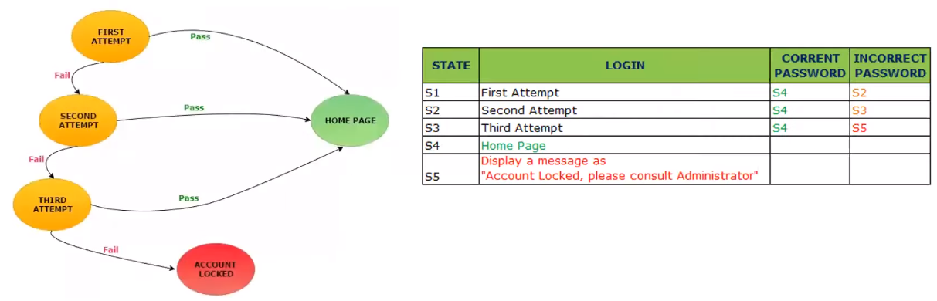

Here we’re allowed to enter password properly 3 times, after 3 times of wrongly entering the password account becomes locked. Here I have 5 states and I can achieve those states if I comply certain rules which are proper or improper (valid or invalid) entering password. After committing one of the conditions, I change the state of software.

**5. Error Guessing.**

This testing technique is **small and simple**. It requires from us just to try and **guess error** that may befall at one or another place; based on **tester’s previous experience**; we don’t follow some specific rules; Big role here plays tester’s **analytical skills**; we don’t refer to any documentations, we just rely on our assumptions, prior testing skills in the past.   
  
Simple examples:

**- Submitting some web form inside the application without inputting any values**, not filling in any fields. – Of course we’re expecting an error here, some sort of caution messages or alert signals. – That’s my guessing

**- Entering wrong symbols inside the input field that’s accepting only numeric** – surely it’s incorrect behavior.

We can employ this testing technique in any testing area at any time.

------------------------------------------

**Topic 19: STLC**

**STLC – Software Testing Life Cycle** – only about Testing phase unlike SDLC process where we considered all the phases throughout whole development process.

Phases (high level):

**- Requirements analysis** (need to know customer requirements before testing)

**- Test Planning**

**- Test Design**

**- Test Execution**

**- Defect/Bug reporting & Tracking**

**- Test Closure**

**STLC is a subset of SDLC**.

We already have discussed requirements analysis phase overall earlier, thus let me proceed further and not stop by.  
  
**1. Test Planning** (What to test? How to test? When to test?)

It represents a document comprising some important things: **what to test**, what are the different scenarios are upon us, **how to test**, how to conduct testing what kind of automation tools use, we have to **specify time**, various time spans for defined testing phases.

**Inputs:**

**Project Plan** (done by project manager – technical reqs, budget, duration of testing), **Functional Requirements** (different features and functionalities are described in high level document)

**Activities:**

**Identify the resources** (hardware, software, people (suppose there’s insufficient number of well-skilled test engineers so we have to conduct recruitment campaigns to lure some high-qualified employees, how many machines are required, done by Test Lead/Test Manager))

**Team formation** (form a team, provide some bonding to impart needed atmosphere)

**Test Estimation** (estimate the time for testing, total duration of developing, coding, testing, for ex.: 3 months to complete the whole project, based on this info need to estimate how much time will testing take: for test execution, bug /fixing phase, test case writing..)

**Preparation of Test Plan** (contains all the planning activities, what to test, what not to test, which people will be involved, when we will be conducting the testing, features to test, also done by management team(test lead/test manager))

**Reviews on Test Plan** (reviewing test plan by the team, may be negotiated with developers, BA)

**Test Plan Sigh-off** (approval by authorities to continue)

**Responsibilities:**

Test Lead/Team Lead (70%), Test Manager (30%)

**Outcome:**

Approved Plan Document

**2. Test Designing**

It’ll start after completion the test planning phase; we should refer some documents – this phase implies **writing the test cases** – main activity.

**Inputs:**

**Project Plan** (which contains timelines, schedule); **Functional Requirements** (what features to test, behavior from software to expect); **Test Plan**; **Design Docs** (HLD, LLD) (UI Level requirements, how many buttons, fonts, colors); **Use cases** (part of functional requirements, they describe the requirements, they help to understand clearly all the flows)

**Activities:**

**Preparation of Test Scenarios** (main one, what to test? Login Box of application – this is a scenario) – like checklist.

**Preparation of Test Cases** (once we identify test scenario/area for testing; Writing Multiple test cases, for one scenario we may create many test cases) Test case – step by step process describing all the actions to check/validate some feature.

**Review on Test cases** (as I complete creating the test cases, I should discuss them with my peers, co-workers, with team members, to help me to add or eliminate some tests, maybe modify some of them), sometimes I might miss some kernel, vital steps or something, something remains uncovered, such reviews may recur several times and may be passed with not only test team but also with developers, managers and so on, main testing goal – catch a bug.

**Traceability Matrix** (some sort of mapping between created test cases and customer requirements, it conventionally represents some excel sheets with tangible coverage of business requirements by test cases), RTM – Requirement Traceability Matrix.

**Test Cases Sign-off** (everybody should sign it – team lead, developer lead, project manager, without it we can not to proceed further, normally we’ll receive this message from all authorized people on email.

**Responsibilities:**

Team Lead/Test Lead (30%), Test Engineers (70%)

**Outcomes:**

Test Cases Document, Traceability Matrix

**3. Test Execution**

Once the test cases are ready and approved we can direct to the test execution phase. One of the important area

**Inputs:**

**Functional Requirements**; **Test Plan**; **Test Cases**; **Build from Development Team** (piece of software) by the time we will have gotten build from developers we’ll compose all the described above documents, listed test plan, test cases and so forth.

**Activities:**

**Executing Test Cases** (those we have written on previous stage, based on the priority we choose which test cases to execute first in the queue, smoke testing in the beginning, sanity testing then, etc.  
  
Whilst we’re executing our test cases, we should simultaneously prepare small document called **test report/test log** containing test results after execution (test passed or failed…)  
  
**Identifying Defects** is one of the main activity, we must check whether expected result equals to actual result and if not we need to create bug report.

**Responsibilities:**

Test Lead/Team Lead (10%), Test Engineers (90%)

**Outcomes:**

Status/Test Reports.

**4. Defect Reporting & Tracking**

During text execution itself defect reporting & tracking phase appears. Simultaneously we prepare the reports after detecting new bugs in the system.

**Inputs:**

Test Cases; Test Report/Test Log

**Activities:**

**Preparation of Defect Report** (we can arrange Excel file to keep all the defects there so we would have an opportunity to refer to this file any time we want, and track current statement of bugs)

**Reporting Defects to Developers** (through Bug-Tracking System, or through corporate social networking system)

**Responsibilities:**

Test Lead/Team Lead (10%), Test Engineers (90%)

**Outcomes:**

Defect Report

**5. Test Closure/Sign-Off**

Stopping our testing, wen all activities are over, conducted all the re-testing processes, re-checked all the bugs which came up earlier. To decide whether it’s time to close the process of testing, we should organize meeting with Test Team.

**Inputs:**

**Test Reports** (we need to review and check if we tested all we had planned), **Defect Reports** (also need to review, maybe there some open bug reports, if that, are they minor or major defects)

**Activities:**

**Analyzing Test Reports**

**Analyzing Bug Reports**

**Evaluating Exit Criteria** (that criteria must be mentioned in the test plan itself, normally it depends on number of defects found during testing phase. For. Ex.: at least 90% tests must pass and no one major bug left)

**Responsibilities:**

Test Lead/Test Manager (70%), Test Engineers (30%)

**Outcomes:**

Test Summary Report (final document combining all the previous test documents together which lately is given to the customer)

--------------------------------------

**Topic 20: Test Plan Contents**

Test plan is a document that describes the test scope, test strategy, objectives, schedule, deliverables and resources required to perform testing for a software product; test plan should be done before testing; we should specify everything, what to test, what should not be tested, and which components enters our scope, what testing strategies we’re going to use, what kind of testing, what time we’re going to conduct testing, on which environment and so on.  
  
Test Plan template contents:

**1. Overview** (what is the project? Small description about project? Why are we preparing test plan document?

**2. Scope** (what to test? What not to test?)  
 - Inclusions  
 - Test Environment  
 - Exclusions

**3. Test strategy** (means what kind of testing we’re going to conduct, smoke, sanity then regression, when we apply automation when manual testing and so on)

**4. Defect Reporting Procedure** (how we’re going to declare the bug, what’s the exact process we follow to grant the found bug to developer)

**5. Roles/Responsibilities** (should be clearly defined in the test plan document, because there are many people inbound to testing team such as test engineer, test lead, test manager and so forth)

**6. Test Schedules** (explains when we must conduct which type of testing, dates and corresponding activities)

**7. Test Deliverables** (every phase of testing we compose set of documents. Like during test design phase we create test cases, check list documents, test report documents, test summary report – all those documents are deliverables)

**8. Pricing** (how much it’ll cost, computed, calculated by management team.)

**9. Entry and Exit Criteria** (criteria according to which we make decisions when to proceed with testing and when to exit from testing phase.)

**10. Suspension and Resumption Criteria** (sometimes we need to immediately stop testing, but after recovery we can resume testing, such criteria should be described here)

**11. Tools** (what kind of tools, including manual ones: Excel Sheets, MS Word, Bug Tracking System and so on)

**12. Risks and Mitigations** (suppose while project is going on some risks show up, like people problem might appear if somebody will get ill and we won’t be able to deliver in time or to proceed or finish testing phase in time; or hardware crashes, so we have to provide mitigation plan, back up.)

**13. Approvals** (who will approve test plan, test cases and other things.)

---------------------------------------

**Topic 21: Use Case, Test Scenario & Test Case, Test Suite**

**Use Case:**

**- describes the requirements** (help us to understand requirements more clear; use cases are also a part of the requirements specified inside the FRS document for better understanding; suppose there are customer’s requirements described only by using solid text, but later managers or business analysts append such requirements into SRS document in the graphical format with pictures and diagrams which is quite convenient to realize all the requirements, because it’s more clear to figure things out presented by visual content. Use cases are created by managers, BA.

- Use case **contains THREE Items**

* **Actor** – simple user, interacting with a process

* **Action** – steps provided by user to achieve the goal

* **Goal/Outcome** – final result received after completion Action.

**Test Scenario:**

- A possible area to be tested (**What to test**); Based upon our use cases we can derive all test scenarios, as a tester I’ll write test scenarios. For each scenario there will be multiple test cases; test scenario might be separate component (scope) of the system. For. Ex.: log in/password box is a test scenario.

**Test Case:**

- Step by step actions to be performed to validate functionality of Application (**How to test**)  
- Test case contains multiple steps, expected result & actual result.  
By using test scenarios we’re able to write test cases.

**Test Suite:**

It’s a **group of test cases** which belong to one particular category. For example, I need to collect all the test cases for sanity testing phase. I may simply consolidate them into one sanity test suit. Or regression test cases I’ll collect as a single unit referring to regression test suite.

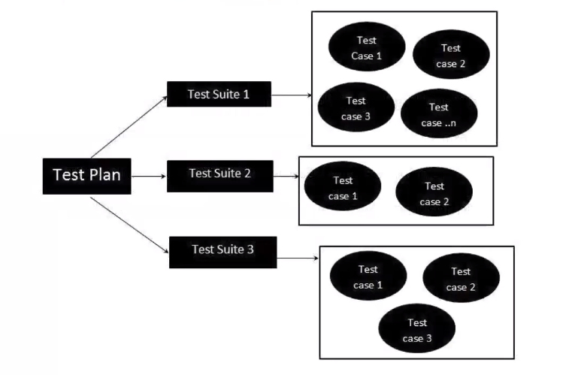

----------------------------------------

**Topic 22: Test Case Contents**

As we already passed it before, test case is a set of action, step by step performance of execution one or another feature of software with expected and actual result in the end. It’s also a document normally at the first stage we prepare them in Excel Sheet before uploading it to JIRA or somewhere else.

**1. Test Case ID** (unique identifier of each Test Case, because there are lots of them)

**2. Test Case Title** (small name of test case, but predictable from one look)

**3. Description** (2-3 lines to describe problem if it’s necessary)

**4. Pre-condition** (what condition should be applied before executing the test case itself)

**5. Priority** (P0, P1, P2, P3 – order, base on the priority we choose which test cases are more serious)

**6. Requirement ID** (which requirement we’re linking to)

**7. Steps/Actions**

**8. Expected result** (according to requirements or logical anticipation we know what result must be)

**9. Actual result** (it can be the same as expected one or it can vary)

**10. Test Data** (some test cases require test data that we have to provide and prepare ahead)

It might look about that:

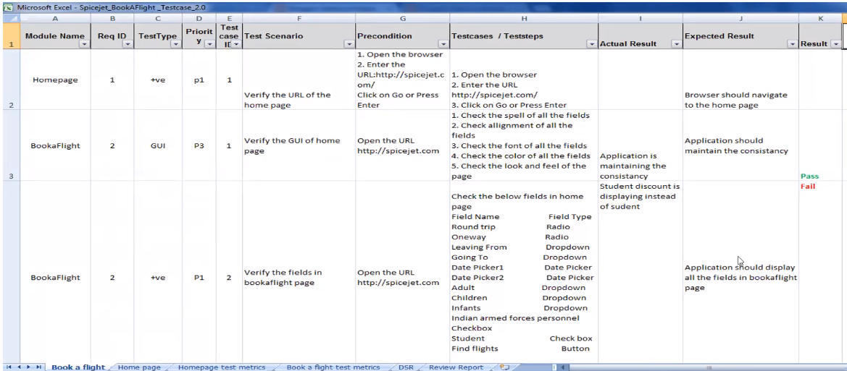

---------------------------------------

**Topic 23: Requirement Traceability Matrix (RTM)**

It describes **mapping of Requirements with Test cases**. Supposedly I have huge number of test cases. But how I would know if they covered all the requirements. RTM comes to the picture here. Because in parallel manner I replenish the traceability matrix while doing my test cases. So, this procedure preferably must be executed on test design phase.

Such traceability matrix usually contains **requirement ID, Description of that requirement and Test case ID’s**. This work belongs to tester.

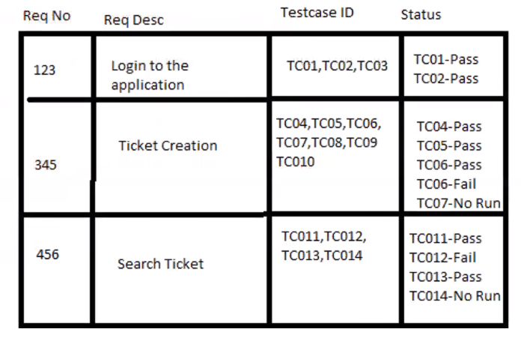

And as we can see on a template above there can be multiple number of test cases that cover one requirement. That’s pretty common state.

---------------------------------------  
  
  
  
  
**Topic 24: Test Environment**

It’s a platform specially build **for tests conduction** on the software product; before testing itself, before getting the created build from the developer testers are supposed to set up their own **QA environment** which should fully **simulates the real/production** environment.

Environment means predefined configured software, hardware along with stable proper internet connection. By these terms we imply how much **RAM** is used by customer, which **CPU** is preset in the customer environment, what **OS**, how fast **internet** connectivity should be.

Therefore, we have to understand whatever environment is used by customer and replicate the same environment. Test Bed is an alias for Test Environment.

-------------------------------

**Topic 25: Test Execution**

Once the developers provide the build to us (testers) we should install it on our environment and carry out the testing.

**Entry criteria**: Test Cases, Test Data, Test Plan, Test Environment

**Activities**:

* Test cases are executed based on the test planning.
* Status of the test cases are marked like Passed, Failed, Blocked…
* Documentation of test results and log defects for failed cases
* All the blocked and failed test cases are assigned bug ids.
* Retesting once the defects are fixed.
* Defects are tracked till closure.

**Deliverables**: Provides defect and test case execution report with completed results.

**Guidelines for Test Execution**:

* The Build being deployed to the QA environment is the most important part of the execution cycle.
* Test execution is done in Quality Assurance (QA) environment.
* Test execution happens in multiple cycles.
* Test execution phase consists of executing the test cases + test scripts(if automation).

--------------------------------------

**Topic 26: Defects/Bugs**

Any **mismatched functionality** found in application is called as Defect/Bug. When I’m executing my test cases on the application, I expect to see some certain result as an outcome, but I get another result, that’d be a bug.

During Test Execution Test Engineers are reporting mismatches as bugs to developers through conventional tools or template. Defect report contains some prominent items.

Defect Reporting Tools:

- Clear Quest; DevTrack; **Jira**; Quality Center; Bug Jilla.

**Defect Report Contents:**

**1. Defect_id** – unique identification number for the defect

**2. Defect Description** – detailed description of the defect including information about the module where defect was found.

**3. Version** – Version of the application I which defect was found

**4. Steps** – Detailed steps along with screenshots with which the developer can reproduce the defects

**5. Date Raised** – Date when the defect is raised

**6. Reference** – where you provide reference to the documents like requirements, design, architecture or even screenshots of the error to help understand the defect

**7. Detected By** – Name/Id of the tester who brought up the defect

**8. Status** – Status of the defect, more on this later

**9. Fixed by** – Name/ID of the developer who fixed it

**10. Date Closed** – Date when defect is closed

**11. Severity** which describes the impact of the defect on the application

**12. Priority** which is related to defect fixing urgency. Severity Priority could be High/Medium/Low based on the impact urgency at which the defect should be fixed respectively.

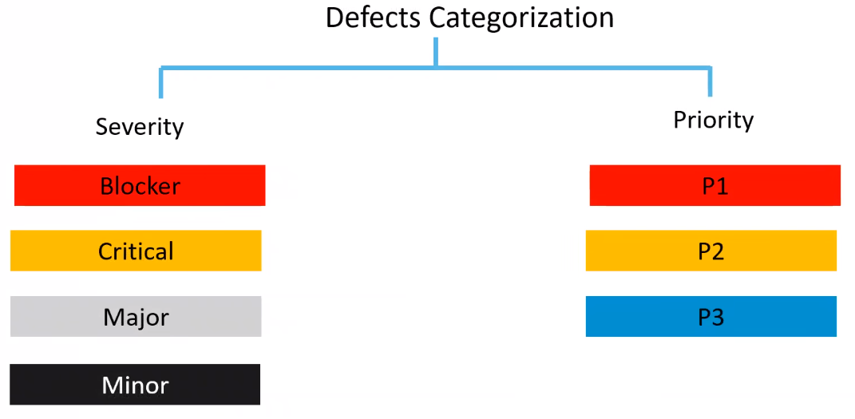

Severity describes **seriousness** of the defect and how large **the impact on Business** workflow.

Normally severity might be divided into **4 categories**:

* **Blocker**: this defect indicates nothing can proceed further; for. Ex: Application crashed, Login Not worked.
* **Critical**: the prominent/basic functionality is not working. Customer business workflow is broken. They cannot proceed further. Ex2.: fund transfer is not working in the banking; Ex2: ordering products in the e-commerce application is not working
* **Major**: it causes some undesirable behavior, but the feature/application is still functional. Ex1: after sending email there’s no confirm message; Ex.2: after booking cab there’s no confirmation
* **Minor**: It won’t cause any major break-down of the system. Ex: look ad feel issues, spelling, allignments.

Priority describes **the importance of defect**. How soon the defect should be fixed.

Defect Priority states the order in which a defect should be fixed.  
Such priorities may be subcategorized **into three tiers**:

* **P0 (High):** the defect must be resolved immediately as it affects the system severely and cannot be used until it’s fixed.
* **P1 (Medium):** It can wait until a new version/build is created.
* **P2 (Low):** developer can fix it in later releases.

Priority can be changed after your assignment it to some level by your team lead or business analyst or project manager, but severity is up to tester only.

Combinations of severity and priority:

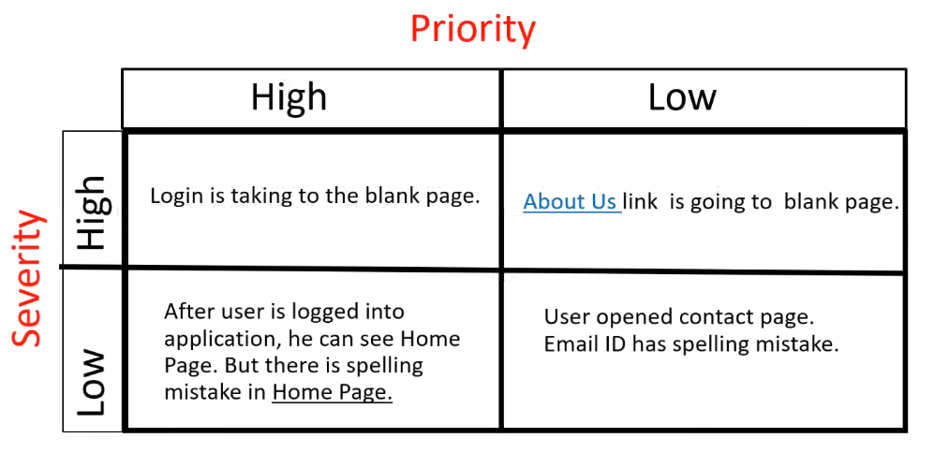

**Defect Resolution:**

It’s a sort of **developer’s opinion concerning created bug**. Developers will provide comment or declaration regarding the defect:

**Resolution Types:**

**- Accept** (bug was accepted by developer and expected to be fixed)

**- Reject** (developer disagrees with tester about this bug)

**- Duplicate** (such bug has already been declared earlier)

**- Enhancement** (misleading with issue’s definition as a bug. It’s rather feature)

**- Need more information** (developer expects tester to provide more details)

**- Not reproducible** (developer cannot reproduce the steps on their environment)

**- Fixed** (bug has been fixed)

**- As designed** (It’s not a bug, It works according to documentation)

---------------------------------  
  
  
  
  
**Topic 27: Defect/Bug Life Cycle**

State of the defect always changes as the process of bug fixing is going.

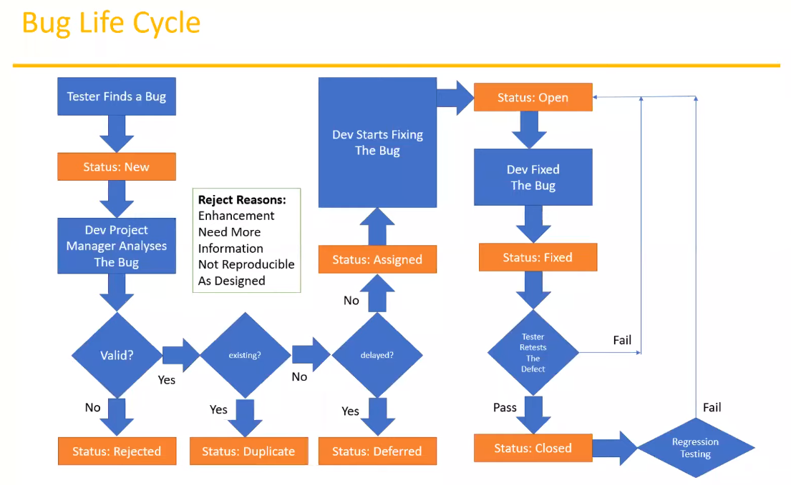

Tester declares a new bug and this bug obtains **status ‘New’** then Developer Team analyzes this bug and decides valid it or not. If not, bug receives **status ‘Rejected’**, the opposite way it goes further and later on there’s a checking if this bug has already been created before. If yes then bug is duplicated (**Duplicate status**), if Not developers’ team is in charge to define whether this bug should be delayed for later fixing (**Status Deferred**) or not. If Not -> bug has **status ‘Assigned’** and one of developers must start fixing the bug whilst bug is ascribed with **status ‘Open’**. After finishing the process of fixing developer conveys this fixed (**status ‘Fixed’**) bug to the tester back and here comes validation part where tester conduct re-test and determine if bug has been fixed or not. If Yes -> **status ‘Closed’**. Else returns to the developer with status ‘Open’ again.

When bug is rejected by a developer there are plural reasons for that. For ex.: **‘Enhancement’** (misunderstanding, confusion regarding that created bug is a feature not a defect) or **‘Need More Information’** (frequent reason implying more information should be provided by the tester so developer would be able to work things out – additional screenshots, log reports whatsoever.) or **‘Not Reproducible’** (sometimes developers can not reproduce bug in their environment) or **‘As Designed’** (means that everything’s working according to designed documentation/customer expectation on this feature).

-------------------------------  
  
  
  
  
**Topic 28: Test Cycle Closure**

At this phase we stop our testing. To do that **we need to meet several criteria** specified in our preliminary documents such as test plan. Criteria might be like that: if we had 100 test cases and later on, we executed all those test cases and 95 % of them got passed and there have not been any P0 and P1 failed tests that means we can close our testing process. Holding in mind that it’s impossible to produce wholly bug-free product. But we have to aspire, seek meet such conditions. We also may organize special meetings with our test team to discuss and decide if we’re ready for test closure.

**Activities:**

* Evaluate cycle completion criteria based on Time, Test coverage, Cost, Software, Critical Business Objectives, Quality
* Prepare test metrics based on the above parameters.
* Document the learning out of the project
* Prepare Test summary report.
* Qualitative and Quantitative reporting of quality of the work product to the customer.
* Test result analysis to find out the defect distribution by type and severity

**Deliverables:**

* Test Closure report
* Test metrics

-------------------------

**Topic 29: Test Metrics**

First of all, we need to make a point of using test metrics anyway. This should be done for management team, to let them know which level of development is going on right now. Let them observe the whole picture of current progress, about pending processes and so on. But before producing the test metrics there must be a collection of required data, we need to adhere to collect them for impending test metrics composing.

* No. of Requirements
* Avg. No. pf Test Cases written per Requirement
* Total No. of Test Cases written for all Requirement
* Total No. of test cases executed
* No. of Test Cases Passed
* No. of Test Cases Failed
* No. of Test Cases Blocked
* No. of Test Cases Un Executed
* Total No. of Defects Identified
* Critical Defects Count
* Higher Defects Count
* Medium Defects Count
* Low Defects Count
* Customer Defects
* No. of Defects found in UAT

Based on this collected data we may proceed with proposing the **prominent formulas** calculating the basic indications regarding test metrics. Here they are:

**- % of test cases Executed**:  
(No. of Test Cases executed / Total No. of Test cases written) * 100

**- % of test cases Not Executed**:  
(No. of Test Cases Not executed / Total No. of Test cases written) * 100

**- % Test cases passed**:  
(No. of Test Cases Passed/ Total No. of Test cases executed) * 100

**- % Test cases failed**:  
(No. of Test Cases failed/ Total No. of Test cases executed) * 100

**- % Test cases blocked**:  
(No. of Test Cases blocked/ Total No. of Test cases executed) * 100

And there are also some additional eligible test metrics we can compute to deduce the whole picture of our current state of testing to contribute to the management team. Here are some defect related metrics:

**Defect Density** (No. of defects identified per requirement/s:  
 No.of defects found / Size (No. of requirements)

**Defects Removal Efficiency** (DRE):  
 (A / A+B) * 100  
 (Fixed Defects / (Fixed Defects + Missed Defects)) * 100   
 A – Defects identified during testing/Fixed defects  
 B – Defects Identified by the customer/Missed Defects

**Defects Leakage**:  
 (No. of defects found in UAT/No. of defects found in testing) * 100

**Defect Rejection Ratio**:  
 (No. of defect rejected/Total No. of defects raised) * 100

**Defect Age**: Fixed date – Reported date

**Customer satisfaction** = No. of complaints per Period of time.

-----------------------

**Topic 30: QA/Testing Activities**

**- Understanding the requirements and functional specification of the application** (main and necessary activity that should be done by a tester in a sense to make things clear with requirements of the customer, to avoid any misunderstanding in upcoming stages, especially in the testing itself)

**- Identifying required Test Scenario**. It literally means that as soon as we figured out the expectation and requirements for some particular feature we must get defined with the exact scope of testing where it will be conducted, what is the flow of testing, without any doubts tester shall adhere to this plan.

**- Designing Test Cases to validate application**. Surely based on determined test scenarios testers are supposed to get dipped into writing suitable test cases. One of the most important activities expecting a lot of efforts and contributions from the tester.

**- Setting up the Test Environment**. Such activity should be completed (and this is recurring information but still) before starting the execution and before tester are given new build from the developer’s team. Test environment must be prepared according to customer’s environment the same hardware, software, internet connectivity.

**- Execute Test Cases to valid Application**. Primary activity of any tester. This is his/her main job as a QA/Tester. Thorough validation is expected from a tester. They must be alert and attentive and responsible while providing the test execution. Reliably validate an application, comply the whole list of rules including writing the defect reports and track every bug till the end.

**- Log Test results**. Here tester should track all the test cases in separate file, either excel sheet or word document file for impending usage. And provisioning the whole tester team with information that you’ve folded into this particular file.

**- Defect reporting and tracking**. Of course, creating of bug reports can be considered as a principal activity from the full list of tester’s actions. After discovering new bug, tester’s mandatory is report it, assign it to a developer and don’t neglect about it but keep an eye on the current status of this issue.

**- Retest fixed defects of previous build**. Undoubtedly, after developer’s completion of bug fixing, we may deploy a new build on our environment and conduct a retesting process to validate whether earlier found bug was fixed or not.

**- Perform disparate types of testing’s in application**. As a tester we conventionally and traditionally adhere to a functional testing, but it wouldn’t be absolutely redundant to be familiar with various types of testing, such as non-functional testing comprising of volume testing, stress testing, performance testing and so on.

**- Reports to Test Lead about the status of assigned task**. It’ll probably not be a substantial and absolutely necessary thing at your project. But there will be some set of rules you’re supposed to stick to. And this activity might be included as a part of regulation. So just keep it in mind.

**- Participate in regular team meetings**. Here I’d like to underline that this event is for one hundred percent paramount/essential. Since such meetings foster to maintain productivity, check the current situation, discuss preliminary possible bugs for upcoming versions and so forth.

**- Creating automation scripts**. As long as you’re professional automation tester you have a special knack for writing automation scripts. There are some places where you might apply your auto tests without any hesitation. But it’s not everywhere.

**- Provides recommendation on whether the system is ready to be released or not**. If you’re are straightly asked this question and you’re cornered you must provide a sincere, proper impartial opinion on this account.

----------------------------------

**Topic 31: 7 Principles of Software Testing.**

* 1. Start software testing at early stages. It means from the beginning when you get the requirements.
* 2. Test the software in order to find the defects.
* 3. Highly impossible to give the bug free software to the customer.
* 4. Should not do Exhaustive testing. It means we should not use the same type of data for testing every time.
* 5. Testing is context based. It means decide what types of testing should be conducted based on type of application.
* 6. We should follow the concept of Pesticide Paradox. It means, if you are executing same cases for longer run, they won’t find any defects. We have to keep update test cases in every cycle/release in order to find more defects.
* 7. We should follow defect clustering. It means some of the modules contains most of the defects. By experience, we can identify such risky modules. 80% of the problems are found in 20% of the modules.

-----------------------------------------------

**Module 2**

**Manual Testing Project:**

* Project introduction
* Understanding & Exploring the functionality (FRS)
* Test Plan
* Writing Test Scenarios
* Writing Test Cases & Reviews
* Environment Setup & Build deployment
* Test Execution
* Bug Reporting & Tracking
* Sanity Testing, Re-testing & Regression Testing
* Test Sign off

-----------------------------

**Chapter 1: Project Introduction**

First of all, we need to emphasize the ground knowledges regarding project. We are going to work with product ‘OpenCart’ being an e-Commerce application. No, I did not misspell, exactly product, not a project.  
  
Normally each eCommerce platform offers distinct set of activities such as:

- Login; - Search for products/items; - Add them to a cart; - Do payment; - Product will be delivered; - Revoke the product; - etc.

So as a customer there’s multiple number of actions I conduct on the site.

If we take a closer look at the eCommerce application, we may notice there are always two parts which this system consists of.

* Front-end (on this side of application I behave as a user/consumer wanting to acquire some products 🡪 this is a public app, coz everybody is able to access it through the internet)
* Backend (Admin site of app: adding the product to the application, removing, receiving the requests about payment, refundable activities, validating registration related processes; intranet – internal connection -> internet configuration providing access to the app only via corporate network).

We’ll have a deal only with frontend applications, filling in the customer’s shoes.

This application is already in there on internet resources. We’re enabled/entitled to attend it right away but It’s not mandatory now, because firstly we need to focus on creating of test documentation.  
  
Preliminary URL link: <https://demo.opencart.com/>

Of course, we can visit it now and wage only exploratory testing. But once again, it’s not imperative at all. It seems like a trifle now.

--------------------------------

**Chapter 2: Understanding & Exploring the functionality (FRS)**

There’s an FRS document composed by authority person: project manager, with arguable help of business analyst. Tester’s team is obliged to understand those requirements. Very important point which should be absorbed by QA engineers.

Here’s a rendering of sample how FRS can look:

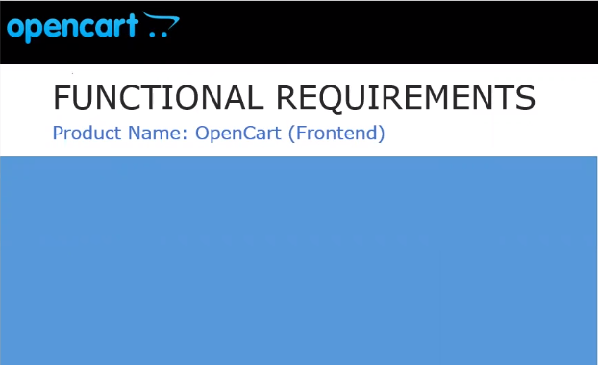

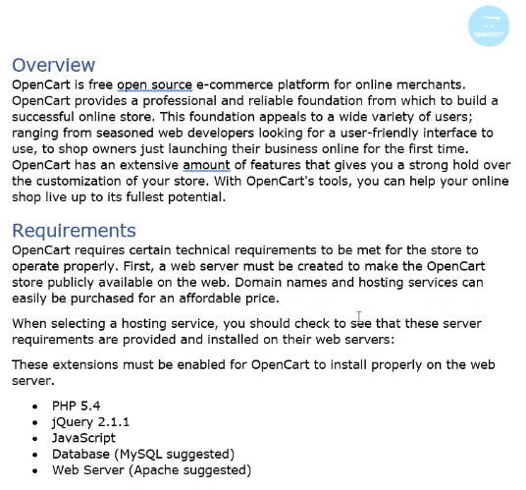

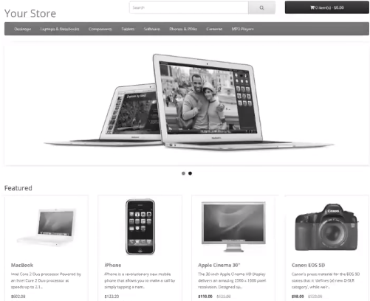

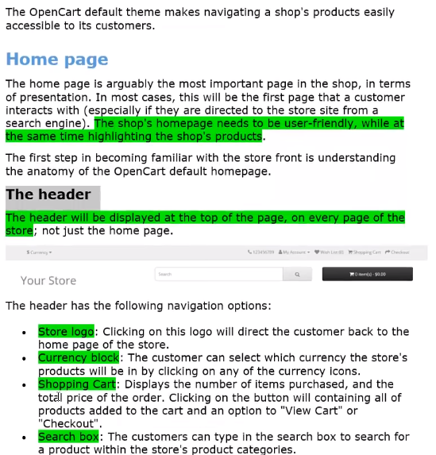

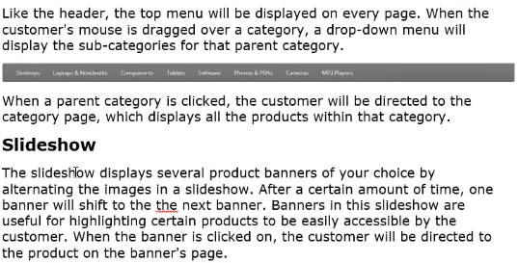

We must thoroughly read, understand, derive some essential points and even underline on top of this document, preliminary copy it to our own place/folder.

------------------------------

**Chapter 3: Test Plan**

Time has come to the point where we need to talk a bit about test plan. I’m gonna render sample test plan of how it might look like in the real project.

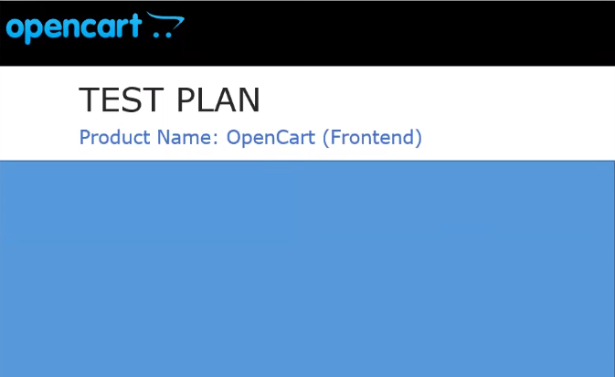

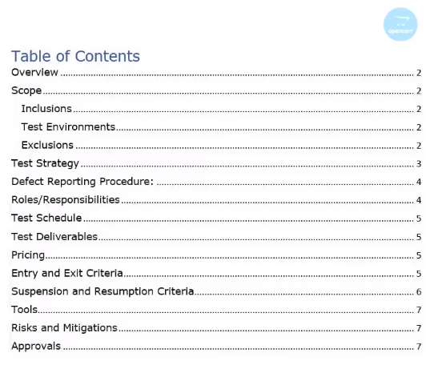

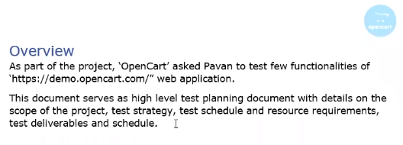

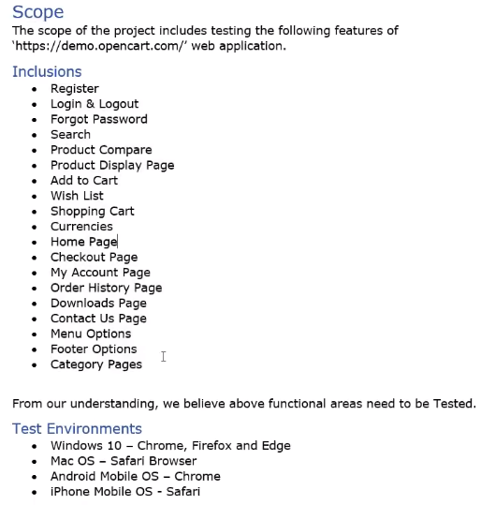

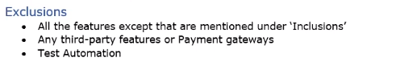

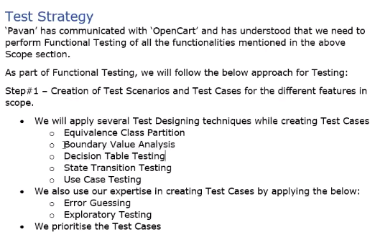

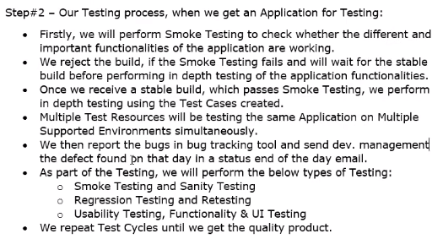

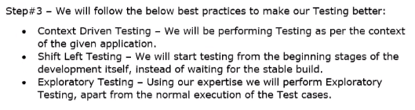

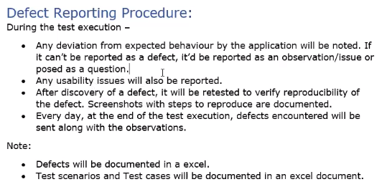

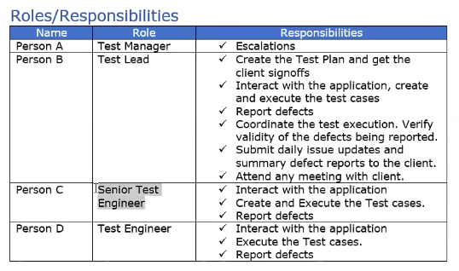

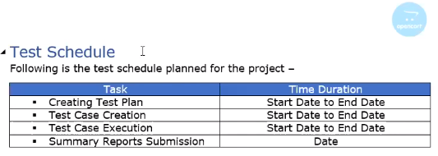

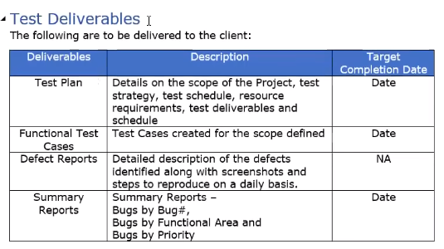

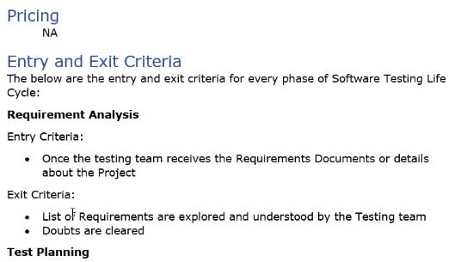

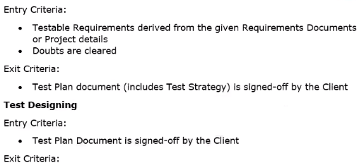

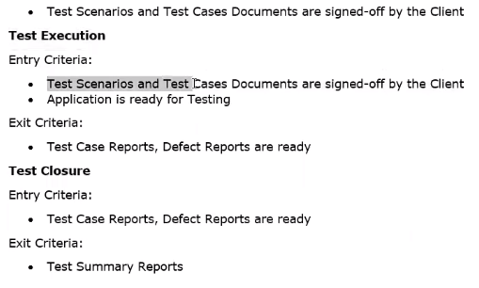

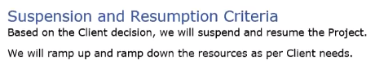

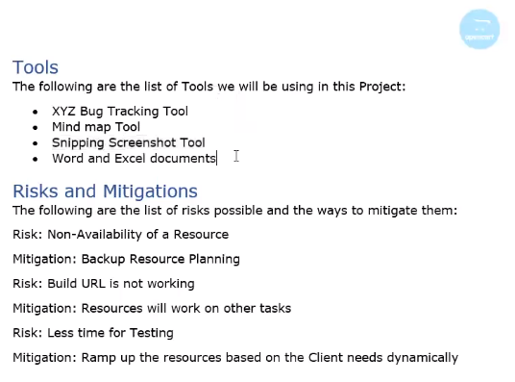

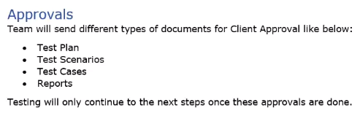

Thus, based on this document (test plan) we may proceed further, we can go on our project and elaborate following documentation.

---------------------------------------

**Chapter 4: Writing Test Scenarios**

Now our jobs consists of preparing the test scenarios, as a rule it’s an excel document where we define all the scenarios according to explored documentation.

Here’s small example of how this test scenarios might be rendered:

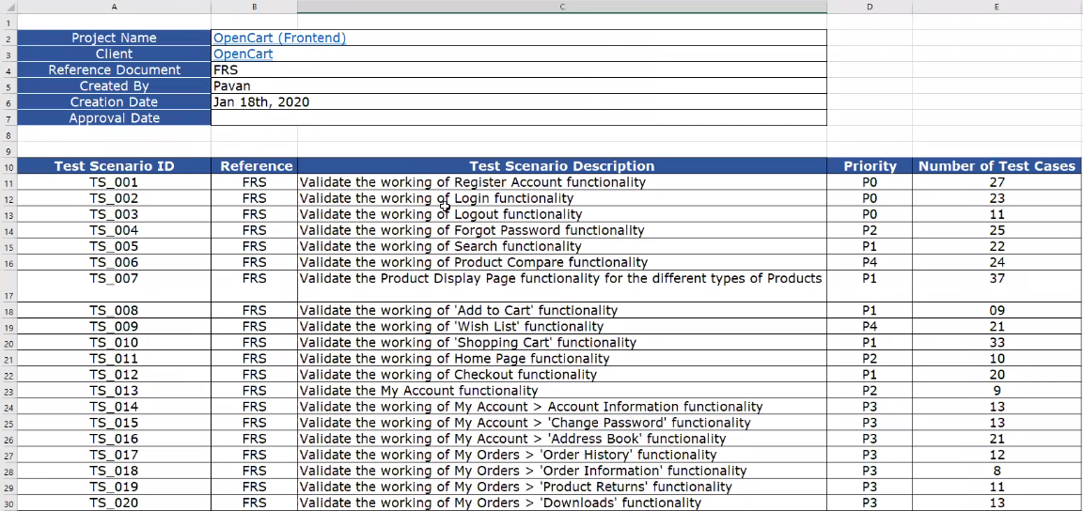 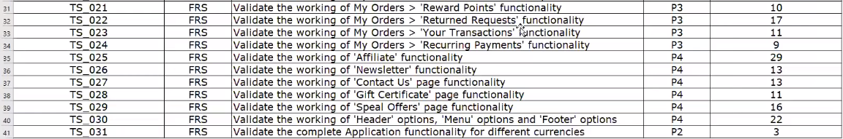



There are listed features to be tested. Out of this document we will further devise the test cases on every test scenario.

-------------------------------------

**Chapter 5: Writing Test Cases**

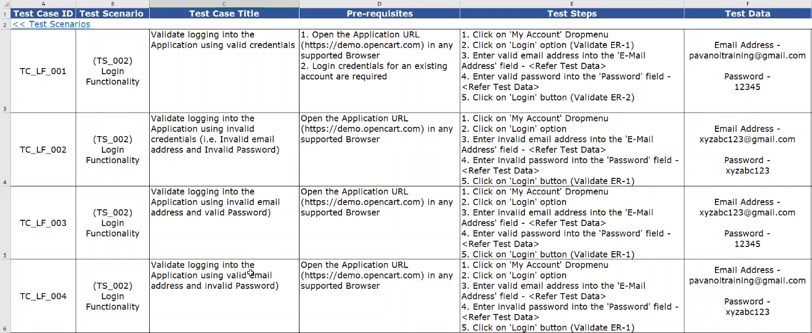

This is how approximately may look the roster of test cases. I just displayed the appearance but in reality there might be slight differentiation.

Now let us take a look at RTM:

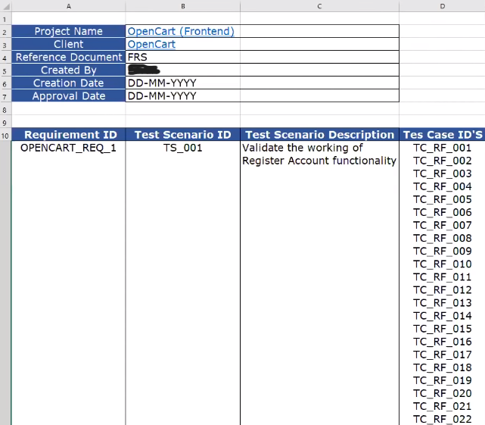

This is called Requirement Traceability Matrix, mapping between requirements, test cases, test scenarios.

**Chapter 6: Environment Setup & Build deployment**

We’re starting by downloading ‘opencart’ host on our local machine.

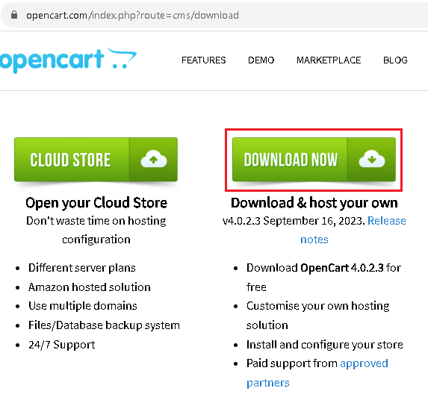

We have to XAMPP opensource application as well to get access to Apache server which is gonna perform as application or web server and MySQL database server.

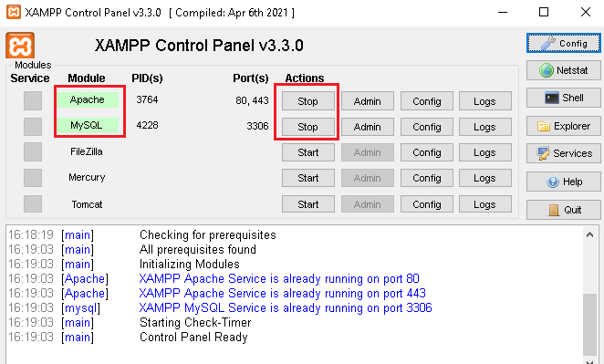

Then I need to unzip and place my downloaded application in a peculiar folder ../xampp/htdocs:

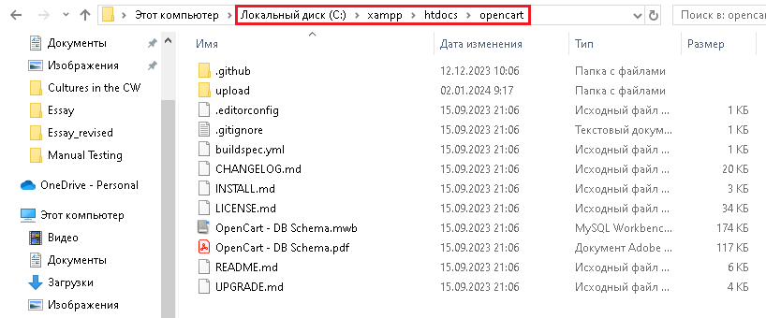

Now I can refer to my database through url: localhost/phpMyAdmin and create new database there which I have named as openshop:

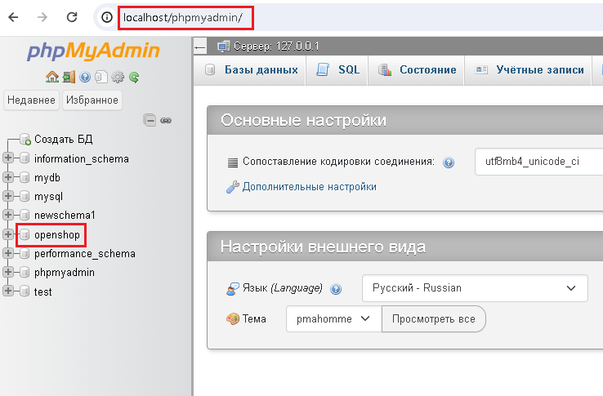

Now I should provide the connection between my application and just created database. For that I’ll employ this particular url link: localhost/opencart, which will unveil following page:

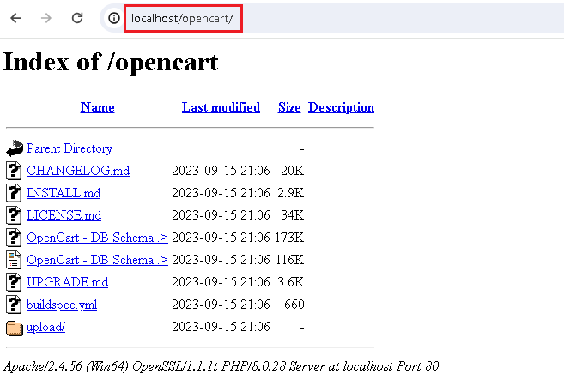

Here comes next activities on the roster: I need to click on ‘upload’ folder then click on ‘continue’ button and ‘confirm’ next page which will lead to configuration tunings:

I’ve put some extra information and click on ‘continue’.

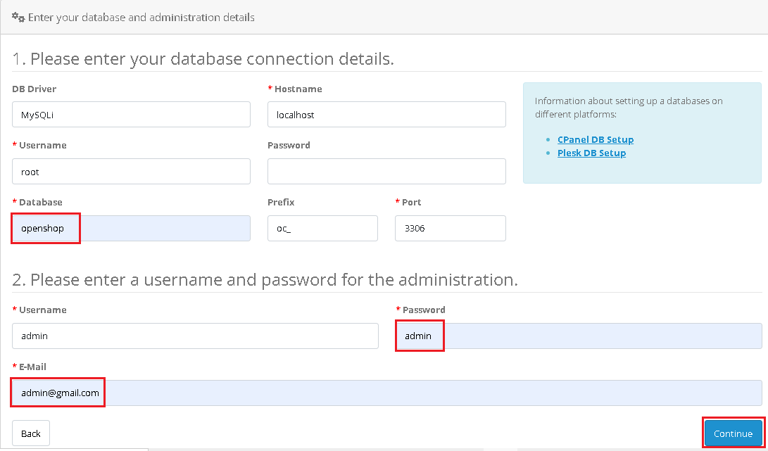

**Chapter 7: Test Execution**

Now we have to complete our signed off test cases and also, it’d not be excessive to execute ad-hoc testing apart from test cases execution.

**Chapter 8: Bug Reporting & Tracking**

I’ bound to report found bugs during test case execution. Normally I need to use JIRA bug-tracking tool or any alternative, similar system, but sometimes I can as well to compose a spare excel sheet for such an occasion and store those bugs in it and later on pitch themto developer as a whole bunch. But it’s kind of obsolete approach.

